UK Observer Training and Handbook 2008

Foreword 2
Introduction 3
Competition ballooning 3
Different tasks 3
Scoring 3
The observer’s role 4
Qualities required 4
Enjoy yourself! 5
Preparation – before you arrive 6
Preparation – in the briefing hall 7
Prior to the flight 8
During the flight – on the ground 10
During the flight - in the air 12
On Landing 14
Marking and measuring the marker 15
Measuring teams 16
Determining the centre of the goal 16
Direct measurement 18
Indirect measurement – GPS 20
GPS loggers 23
Indirect measurement – pacing 24
Indirect measurement – trigonometry 25
Working out co-ordinates 26
Leaving the pilot 27
Observer Logbook 28
Debriefing 29
The tasks – including key points for observers 30
For all tasks 30
Pilot declared goal (15.1) 30
Judge declared goal (15.2) 30
Hesitation Waltz (15.3) 30
Fly in (15.4) 30
Fly on (15.5) 31
Gordon Bennett Memorial (15.8) 31
Elbow (15.11) and Land run (15.12) and Angle (15.19) 31
Minimum distance (15.13) 32
Minimum distance double drop (15.15) and Maximum distance double drop (15.18) 32
Appendix I - Sample observer report sheet 33
Appendix II - Guidelines for Observer Development and Selection 35

Foreword

According to the rules, “An Observer is a competition official, responsible to the Chief Observer. The duties are primarily the impartial recording of particulars of positions, times, distances etc. achieved during a flight. The observer also has the duty to report any apparent infringement of these rules or of air law, and any case of inconsiderate behaviour towards landowners or the public by any competitor or crew member.”

The short version is that you are there to impartially measure marker positions and ensure your pilot, or any other pilot, does not break the rules during the flight.

Observing is also an excellent way to become involved in the highest level of competition ballooning. OK, it can be quite demanding at times, but I have always enjoyed it.

Good luck!

Rupert Stanley
(May 2003)

This document has been written to assist in the training of new observers and to keep existing observers up to date, especially on the use of GPS and GPS loggers. It is intended to be a step by step guide that you can keep in your observer bag. It is not intended to replace the ‘Model Competition Observer Handbook’ issued by the FAI, although this does repeat some of that document, and this document does not relieve you of the need to read and understand the rules.

Rule references are from the 2008 model rules and the numbering in subsequent rules may alter.

Introduction

Competition ballooning

In most respects, Competition Ballooning is very like any leisure flying at a balloon meet. The equipment is generally the same; the conditions when you can fly are the same, although because of their higher skill levels competition pilots will sometimes fly in slightly faster conditions than less experienced pilots. Most important, safety considerations remain paramount.

The competitive element comes from the tasks set for the pilots. The Competition Director devises these to test the pilot’s ability to fly the balloon accurately, and there might be anything from one to five tasks set for a single flight, depending on the conditions. More tasks tend to be set for morning flights than in the evening, as winds are generally more ‘steerable’ in the mornings.

In the early days of competition, results came by measuring where a balloon landed, but as pilots became more skilled, too many were trying to land at the same spot, so nowadays balloons do not land on or near the goal itself. Markers are used instead. These are weighted streamers made of balloon fabric thrown at the target. Once these were introduced, it became possible to have multi–task flights.

Different tasks

A Competition Director can choose from 18 different tasks, although only about 6 are used regularly. These can be put broadly into two classifications.

The first group require the pilot to use the winds available to fly to set targets. For example, in a Judge Declared Goal, the target is set by the director. In the second group, the pilot has to predict the direction of the wind, set his or her own goal accordingly (within certain parameters), and then fly to the chosen target (e.g. a Pilot Declared Goal). Conversely the director might set a goal, and pilots have to take off a certain distance away at a place of their choosing, and fly to the target - this is called a Fly–In.

In this country goals tend to be road junctions in country areas, but at some competitions large crosses or bulls–eyes are used. The majority of tasks fall within these categories, but there are occasionally others; for example in a Minimum Distance the pilot basically has to attempt to go nowhere. This task might be set on a very still morning.

Scoring

Points are awarded for each task. The winner is always awarded 1000 points, and the other pilots get points according to mathematical formulae linked to their accuracy relative to the winner, or their position in that task. Points can also be deducted for infringements of the rules. Observers do not become involved in the scoring.

The overall winner is the pilot who achieves the most points in the course of a competition, and in practice this is often not the pilot who wins the most tasks; it is generally the pilot who is most consistent.

The observer’s role

Obviously the Competition Director and the team of officials cannot be everywhere with all the balloons during the course of a flight. This is where the observer comes in. You are there to be the eyes of the director, note all that happens, and report back. Purely that. You should know the rules, but it is never your job to interpret them.

Your most important job is to identify and record the position of each marker. Sometimes you will be expected to do this from the ground, and you will be taken around with the team in the vehicle. They should do their best to keep you in contact with the balloon. If the markers are easily found, you may well measure them as you go. There will be other occasions when the pilot will invite you to fly, and you will observe marker drops from the air, and go back to measure their position after the flight.

In the UK each pilot has to provide an observer for each competition. Many pilots have their own regular observer, but some use ‘freelance’ observers. At every pre–flight briefing, each observer is allocated to a pilot (but never the one that he or she has come with, and usually not to a pilot you have observed before at that competition). In most other countries, and at international competitions, arrangements for observers are independent of pilots, though their function is the same.

In simple terms, the observer’s job is to monitor the flight, record and measure where the markers land, and report back to the Director via Debriefers. In practice the observer has a form to fill in, which is largely self–explanatory. There are boxes for the time inflation started, time of take–off and so on, and spaces for diagrams to show where markers landed, how they were measured, and finally to show where and when the balloon landed. If you are lucky you are able to make a direct measure to the goal, but if the marker is too far away, you have to be able to pinpoint the marker relative to some other suitable feature on the map. In practice this is not usually a problem, and new observers soon pick up the techniques needed.

Qualities required

Good map–reading skills and a good understanding of map co–ordinates. Patience and tact. Ability to produce clear and simple sketch maps (works of art are not required, and you soon learn the important features that need to be shown). The ability to stay quiet, unobtrusive and detached when necessary. Reasonable fitness and stamina, and of medium build or less. Self–confidence - in this country you will find you are normally working with the pilot’s support, and conflicts will be rare, but there will be odd occasions when you need to stick to your guns, and not allow yourself to be brow–beaten. In the final analysis, you must simply record what you have seen, and leave the competition team to sort out any differences in interpretation.

Enjoy yourself!

Competitive ballooning at all levels, both nationally and internationally, is a very friendly sport. Pilots tend to compete with each other rather than against each other, and it is quite usual to find competitors discussing the tasks in some detail beforehand and sharing information about the wind conditions during a flight.

Downsides are few, but perhaps the worst is that once the flight is over, the balloon is packed away and all the markers are measured, the observer still has to wait at the competition centre to convey his or her findings to the debriefing team. Also if you go to a competition where there are flights morning and evening at every opportunity, you can end up pretty tired.

On the plus side, you have the opportunity to observe (in both senses of the word) and sometimes fly with first–rate pilots, see how they use the wind to steer, and look for breezes that no–one else can find. Once you have built up enough experience at home, you will be able to go to international meets, often with a contribution to your expenses. Many experienced observers now have a network of good friends worldwide as a result.

Observing is a first–rate way for anyone interested in ballooning to see the best in action; for people who crew for just one pilot to widen their involvement; for new and prospective pilots to continue developing their skills by watching how good competition pilots operate; and for those who have no intention of becoming pilots to see how expert crews function.

But far and away the best reason to become an Observer is that it is simply a great way to enjoy yourself!

Preparation – before you arrive

To a great extent, what you need for observing is just normal ballooning gear plus a few goodies. The goodies may be supplied by the pilot who nominated you, or you may have your own.

Items that you really need are:

- Competition maps, marked with the current sensitive areas
- A copy of the rules – AND PLEASE READ THEM!
- A long tape measure, ideally 50m and not made of metal (as this tends to snap when driven over), try your local builders merchant or www.screwfix.com
- A watch with a seconds hand or ideally a digital watch with a stopwatch function
- A roamer (I would recommend the Basic Roamer 6 in clear plastic from http://www.ukmotorsport.com/basic/roamervi.html), although you can just make do with a good ruler. We have been given a small supply of roamers by balloon manufacturers which I can supply you with if you ask
- A clipboard with pens, pencil and paper
- A compass (the magnetic directional kind, ideally a ‘sighting compass’)
- A can of spray paint. If you are worried about painting roads/fields, you could use that fake Christmas snow which is temporary, or chalk, but neither of these are suitable for damp/wet conditions.

Items that are not necessary, but quite useful are:

- A torch (for finding/measuring after dark)
- Mini post-it notes or sticky arrows (for identifying goals and marker drops)
- A plastic bag (for those wet markers)
- GPS (and spare batteries)
- Binoculars
- Magnifying glass
- Small snacks and a drink
- A few lengths of light plastic hazard warning tape (to aid returning to the same spot to measure)
- A high visibility vest

Preparation – in the briefing hall

You should aim to get to the first briefing about 15 minutes early and subsequent briefings about 10 minutes early. This should enable you to check the notice board for new sensitive areas or other new information and also to check the observer list to see which pilot you have been allocated to for that flight. You should be prepared to leave with your pilot immediately at the end of the briefing without any delays.

You should sit with your assigned pilot – there should be a list on the entrance door. They will generally have a competition number and the seating will be similarly numbered so you will know where to sit. If you are uncertain who your pilot is, do ask one of the other observers.

You will normally be given your own copy of the tasks set for that flight, take the time to read these and think about the different implications for observing – there is a section at the end with some thoughts on the main tasks. It is also worth reading the rules which describe that task. When you are on the launchfield, take the opportunity to compare notes with other observers. The Chief Observer may also make some comments on the tasks if appropriate.

If goal co-ordinates are given, use the time you have to find those goals and mark them on your map (I use mini post-it notes). Do check the details of the task in the rules if you need to.

Listen carefully to the briefing as this may well correct or amend some of the task information you have previously been given.

At the end of the briefing, follow your pilot closely, some like to make a quick exit and can easily lose you in the crowd.

Prior to the flight

If you are not launching from a common launch point, ensure you follow your route carefully on the map as you drive out.

If you did not have time to mark goals in the briefing hall, do it on the launch site whilst the crew prepare the balloon.

You should stay near your pilot whilst he does his flight planning in case he wishes to nominate a provisional goal on your observer sheet. This is optional and should not be prompted by you. Any provisional goal should only be written on by the pilot to save disagreement later.

Do not engage in discussions or interpretations of the rules or the task with the pilot or crew, it is for them to make the best of the information they have, you are only there to observe.

It is fairly common practice for an observer to help during inflation, particularly with small crews, and it can assist relations if you offer, but only if you are happy to do so and are fully prepared for the flight. In any case, you should keep your bag or clipboard with you in case the pilot wishes to change his provisional goal.

If you enjoy photography, and have completed your pre-flight preparation, then do take photos, but remember that your role is as an observer, so stay close to your pilot and alert to what he and the crew are doing.

If GPS loggers are being used, you should observe the pilot switching the unit on and attaching it to a ring attached to the bottom of the envelope. There is no need to ensure the unit acquires satellites, but you could take a moment to ensure your watch is set to GPS time if you have not already done so.

When the balloon is inflated, the pilot will be given permission to take off by a launch-master and a sticker will sometimes be put on your form to indicate that permission was given. There are various times to record for these activities and it can be important to record the seconds as well. Get a good look at the balloon to memorise distinguishing marks as it can be tricky to spot your balloon amongst the pack once it is in the air and you are some distance away.

Your pilot may invite you to fly. Some pilots always fly their observer, others never and the remainder do when they think it may be advantageous to a particular task set on that flight. YOU DO NOT HAVE TO FLY. IF YOU DO NOT WISH TO FOR ANY REASON, THEN SAY SO. YOU DO NOT HAVE TO JUSTIFY YOUR DECISION TO THE PILOT. If you know prior to the event that you do not want to fly, say due to a bad back etc, then do let the Chief Observer know so you can be put with a pilot that rarely flies their observer. Sometime you may be invited to fly whilst in the briefing hall or on the way to the launch field, at other times, the pilot may have inflated the balloon and be about to take off when you are asked to fly – be ready!

Rule 3.7 says that each balloon shall carry an altimeter, so make sure you see one, ask if you do not see one. If you think you may be flying, you should ensure that the altimeter is set correctly, either by checking your height on the map back to the altimeter or checking the QNH setting. You should be able to quietly check this prior to launch, but once again, ask if you are unable to do so. The reason for the check is to judge possible PZ infringement if you are in the basket.

Rule 12.7 says that the markers must be visible in the basket at take-off, so make sure you see them!

During the flight – on the ground

The crew will typically wish to drive away as soon as possible once the balloon has departed, so once again, be ready – especially if you are taking photos.

You should be offered a window seat so you can observer the balloon. You may be asked to map read for the driver – this is uncommon but you would typically be expected to help out (after all, you need to follow progress on the map as well) although it is their risk if you take them the wrong way!

You should know where you are on the map at all times – use a pencil and/or post-its to follow the route or mark your position when you stop. Practice identifying footpaths and side roads as you go. If you lose your place, do not be afraid to ask the crew where you are and then verify that yourself.

Be aware that the pilot may not always drop very close to the goal, especially if the wind is not working out as forecast. You will often get a warning from the pilot via the radio to the crew, but not always, hence you need to watch the balloon and know where you are on the map.

If the balloon is obviously going to miss the goal by quite a distance, there is no point in going to the goal. It is far better to go to the point where you anticipate the marker is to be dropped, so you are ready. You should normally be guided by the crew in this, it is their job to get you to the marker and you should not insist that they drive to or stop at a particular place unless you think they are a bit clueless or deliberately trying to keep you away. You should pay particular attention to this is you are aware that they are using a second car.

You should note the time (including the seconds) you see the marker leave the basket. However, if you have not observed the drop yourself (maybe it was too far away to see), do not record a time, as you have not actually observed anything. The use of GPS loggers provides additional information that may be of use if the marker is lost. To enable the debriefers to use this information, it is especially important that you observer the marker leaving the basket and note the time. If you are on the ground, encourage the crew to warn you of a drop and if the balloon is high or a long way away, use binoculars if any are available.

It is up to the crew to decide whether you should measure the marker immediately or go with them to collect the pilot. It is quite common for the crew to ask you to simply spray the marker and then to come back later to measure it. This means that even if the marker is subsequently stolen, the pilot will have a marked position to measure from. If you have a digital camera, it is worth a couple of quick photos to enable you to find the position again or provide evidence of the position if the marker has been moved or stolen. If the next task is a Fly On, you should also note all co-ordinates written on the tail of the marker. If you do leave a marker that is not on a road, leave some form of indication nearby (such as arrow sprayed at the edge of the tarmac) to help you return straight to the spot. If you have a GPS, storing a waypoint is the obvious method.

Whilst your job is principally to observe your own balloon, you should also note infringements by your own or other balloons, which would typically be PZ infringements or ground contact. For either of these, you should report both your own position (co-ordinates) and that of the other balloon(s) and any other information that you think may be necessary to prove your observations, especially as PZ infringements are difficult to prove. Under rule 6.4, a competitor (typically your own pilot) can request you to ‘record or witness any particular piece of information’ – it is your duty to do so and report that at debriefing, your opinion of who is right or wrong should not be brought to bear in this situation. If there are other observers around who have seen the infringement, check they have noted it down too.

If you come across another marker, it is good practice to spray the position and briefly note the position yourself. If the marker has Fly On co-ordinates on the tail, note those down too.

During the flight - in the air

As mentioned previously, you have no obligation to fly if you do not wish to, but for most observers, this is the highlight.

If you are asked to fly, you should take the minimum amount of gear with you. Pilots can get a bit annoyed if the observer tumbles into the basket with backpack, camera bag, sweaters etc. I normally just try to take my clipboard and relevant maps with me, leaving my observer bag in the retrieve. Some observers have a light cloth bag to carry the essentials, and this can easily be tied to one of the basket handles to keep it out of the way. Try to avoid the embarrassing situation where your stuff goes all over the place during a positive landing.

Rule 6.6 says that “An Observer may not take a camera on board or engage in photography while flying, except by permission of the competitor, or if required by his duties.” So ask beforehand – I have never been refused, but once again, ensure that your photography does not get in the way of your responsibilities. If you have a digital camera, it could be quite valuable to take a picture of the position of the marker as it hits the ground, but you are not required to do so.

Speak only when spoken to, or if you need to warn the pilot of some safety information such as a power line you think he may not have seen, or balloons climbing from below. Be prepared to be pushed around the basket – the pilot may want to change position instantly and frequently. You should learn to anticipate this. In short, try to become invisible.

Once again, you should know where you are at all times on the map. It is also worth marking the track during the flight.

When the pilot drops the marker, note the time and then follow the marker until it lands, this is normally easier from the back of the basket. Remember that the marker will carry some forward momentum from the flight, and this is especially evident when a drop is made from height as you will only get an impression of forward movement as it approaches the ground. As you will already know where you are, what you should sketch out is sufficient detail to enable you to find the marker on the ground, or get a very good estimate of its position if it has gone by the time you get there again. I have always found a rough sheet of paper useful at this time, transferring a clearer sketch to the actual report form. Features worth sketching/counting are:

- The direction the marker was travelling in, especially if dropped from height
- White lines on the road
- Hedges
- Trees in hedges
- Gaps in hedges
- Roads
- Tracks
- Tramlines in crops
- Wires, poles & pylons (telephone/electrical)
- Buildings

The sketch below is intended to show the position of the marker in a field with visible tramlines and two large trees growing in the hedge.

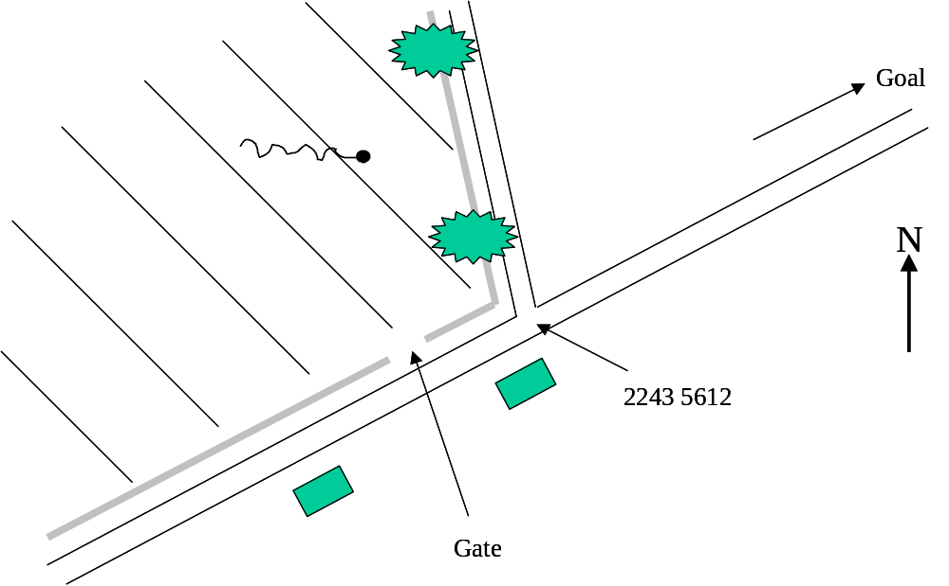

Only an official or observer can touch a marker on the ground. If your pilot drops at a busy goal with other observers present, you can normally call out to a fellow observer to spray the marker for you. If your pilot drops at another location where only the crew are present, it is acceptable for you to observe them spray the marker whilst under your observation but they should not remove the marker.

The only point at which you may be forgiven not knowing where you are is on landing, because you have tucked you clipboard and maps behind a tank and are preparing for landing. In that case, you can check your position by GPS or other means on the ground, the only two things you really need to be aware of is possible PZ infringement or landing within 200m of a goal or marker.

Whilst your job is principally to observe your own balloon, you should also note infringements by your own or other balloons, which would typically be PZ infringements or ground contact. For either of these, you should report both your own position (altitude and co-ordinates) and that of the other balloon(s) and any other information that you think may be necessary to prove your observations, especially as PZ infringements are difficult to prove. Under rule 6.4, a competitor (typically your own pilot) can request you to ‘record or witness any particular piece of information’ – it is your duty to do so and report that at debriefing, your opinion of who is right or wrong should not be brought to bear in this situation.
This paragraph has been deliberately repeated from the previous section in case you only read the section relevant to you.

On Landing

The main concerns on landing are:

- possible PZ infringement
- landing within 200m of a goal or marker
- competition landing, which is when the pilot has not dropped his marker

If any of these may have occurred, you should treat the landing position as if it were a marker drop and conduct measurements and make sketches accordingly. In the case of a contest landing, the pilot should not move the basket until you have arrived, the relevant position being the final resting position of the basket. If you have not yet found the last marker, it is still possible that the landing position may become a contest landing if that marker is not found, so it may be worth spraying the position in case you need to return later to measure properly.

If none of the above has occurred, all you need do is note the co-ordinates, time of landing and whether the landing or the crew caused any damage.

Whilst it is the responsibility of the pilot or crew to obtain landowner permission, it is normal practice for the observer to go with the crew to witness this and record the landowner details.

Use the time available to you whilst the crew pack the balloon away to complete as much of your observer sheet as you are able to at this time.

Marking and measuring the marker

It is the duty of the crew to assist in your search for the marker. Having said that, you should be able to see them at all times to prevent the opportunity to interfere with the marker presenting itself. If too many want to help, tell the pilot how many you would like. This will depend on the terrain and visibility. The crew should not touch the marker until you have arrived on the scene, sprayed the position and checked the competition number. It is your responsibility to bring the markers back to debriefing unless you know the measuring team are taking your marker back from a specific task.

At the briefing, the search period will be announced. This is the time allowed to find a marker and starts at the beginning of the launch period. If you were flying in the balloon and will be able to pinpoint the position of the marker (even if it has gone by the time you return to measure it), that can be considered ‘found’. You may take further time after the end of the search period to complete measurements. If your pilot obtains an extension to the search period, note this on your form.

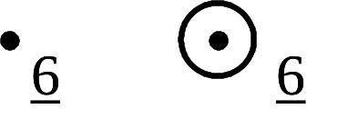
Once you have found your marker, the first thing to do is to check the number on the marker is that of your pilot. If so, spray the ground on the corner of the marker closest to the goal and spray the number next to it. You should either spray just a spot, or a spot in a circle, see following sketch. In the event of later dispute, the point can then be found and checked if necessary. You should also check that the tail of the marker has been fully unfurled (rule 12.10) and that the colour is correct for that task.

Even if the marker is not that of your pilot, it is good practice to spray it, move the tail into a more visible position and make a rough note of the number, location and any Fly On co-ordinates on the tail in case your fellow observer for that pilot is unable to find that marker. You should also show which marker is nearest the goal. Good sketches of the relative positions of markers are sometimes invaluable to the Operations Team. If there are other observers around, discuss the positions with them – your decisions made on the ground are better than any that can be made later in the Competition Centre.

The purpose of your sketch map is to provide evidence of the location of the marker and provide sufficient information that any official can find the location of that drop at a later time solely by using your map, quite possibly without you being there. From the ‘in the air’ section, features worth sketching/counting are:

- White lines on the road
- Hedges
- Trees in hedges
- Gaps in hedges
- Roads
- Tracks
- Tramlines in crops
- Wires (telephone/electrical)
- Buildings

You should also note the time you found the marker and report any suspicions you have that the marker may have been moved. If you were in the air, you should have a very good idea of the location of the marker, even if it was subsequently moved or taken. If the marker has gone by the time you get there but you are confident that you can pin point its landing spot, find that place and measure from there. If you cannot pinpoint the landing position, you can use your ‘least advantageous’ interpretation (rule 12.15.2) of the position as the point to measure from.

Some guidance on ‘least advantageous position’ by way of example on the assumption you were in the air and saw the marker land:

- on a road and you had good reference points by which to note its position, you should be able to find its exact position and measure from that.
- in a hedge somewhere between the second and third tree. In the absence of stronger evidence, your ‘least advantageous position’ may be whichever tree is further from the goal.
- in a field somewhere between the road and a stream. You know it landed in that field, but without further observations, your ‘least advantageous position’ would be the furthest corner of the field (using the stream as a boundary) from the goal.

If the pilot asks you to measure from a different point, you should do so, but also measure from your estimate of the least advantageous position and present both measurements at debriefing.

Measuring teams

A measuring team may be present at a common goal, you will typically be informed of this at the task briefing. They will typically measure markers within a specified area such as the field where the goal is positioned.

If your pilot has made a good drop near the goal and you saw an official mark the position of the marker as it landed, you can be certain that they will measure it. If your pilot dropped in the far corner of the field, you should check whether the measuring team have seen it and know where to find it and whether they will measure it for you. If in doubt, mark the marker yourself and return later to see if it got measured – the team will sometimes leave a list of the measured markers on the gate and take them back for you (note the details announced at the task briefing).

Determining the centre of the goal

Goals basically come down to two forms:

- those set out by the officials where a large target will be set out in a field, and
- those at a road intersection

In the first instance, the job has been done for you and measuring should have taken place whilst the goal was still in place or failing that, the officials will leave a cross in a circle to indicate where the goal had been. They will also take a GPS reading for you.

In the second instance, it is for the observer to determine the centre of the junction. There are two commonly used methods; in the UK we tend to use the ‘largest circle’, the alternative being ‘extrapolated centrelines’.

You need only mark the goal if you think you will need to measure directly to it, otherwise, bear in mind the general procedure as you should try to stand at the goal for GPS measurements. If you are on the ground, arrive early at a goal and think your pilot will be able to drop close to that goal, use the time to mark the centre of the junction – it is preferable to do this in advance of the drop than afterwards when the pilot has an incentive to influence your centre measurement in a certain direction.

We will only deal with the largest circle method. By this method, we determine that the centre of the junction is at the centre of the largest circle that can be accommodated within the area of the hard surface of the roads at a junction. Written here, that sounds very simple; the reality can be a little more challenging, especially as the centre is rarely where the white lines are.

In the case of surfaced roads, use the edge of the road surface. For other surfaces, it is time to use your initiative. We often use a junction that is part unsurfaced road, and in this instance, it is normal to measure up to the start of the grass/vegetation. At a T junction, there are three points to measure to, at a cross roads, there will be four.

To actually measure the centre point, you need your tape measure and another observer or a handy crew person. You should make a first guess at the centre point, stand there and ask your assistant to take the zero end of the tape and walk between the inner edges of the junction. By a process of trial and error, paying out more/less tape and moving yourself to different points, you will find that the length of the tape does not vary as your assistant moves between the relevant points. If the road is at all busy, leave a stone at your first guess and then move it as your trials produce less errors. Your centre does not have to be millimetre precise.

Once you have found the point, mark it with a cross in a circle, about 2 feet in length. You may find that the centre has already been marked, in which case, you should use that first mark. However, if the previous mark looks quite wrong, remeasure and mark your own estimate of the centre, then measure the marker to both ‘goals’ and bring the problem back to the eager debriefers who will resolve it and ensure other markers measured to the same goal are scored consistently. To facilitate this, you should make a particularly detailed sketch including measurements and bearings between the two marked ‘goals’.

There are a few classic tricky situations. One is when the map shows a crossroads but the reality is a staggered crossroads. In this situation, measure the centre of both of these mini junctions, then measure the mid point between the two centres and use this as your goal. Another is where a junction has developed a little grass island. You should assume that the island does not exist, but is instead road surface and measure as normal.
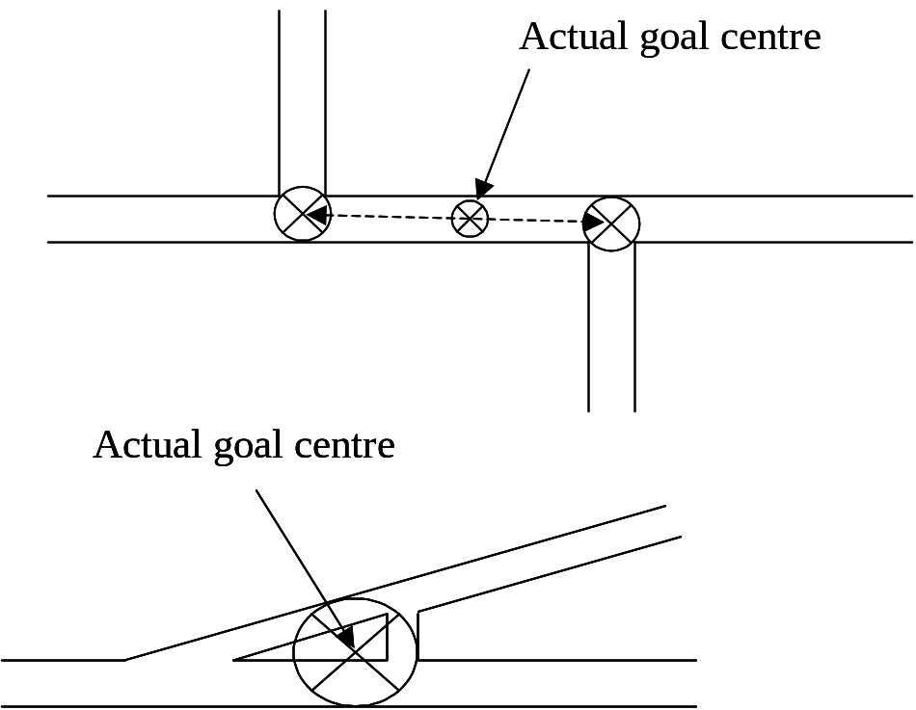

Direct measurement

Direct measurement from the marker to the goal by use of a tape measure is the most accurate method and should be used wherever possible when the marker is within 200m of the goal. First determine the centre of the goal, then measure from the corner of the weighted bag of the marker closest to the goal, to the centre of that goal. Don’t forget to spray the drop position before you start measuring.

If you are measuring on a road, please bear in mind that local drivers will not be expecting to find people milling about in the centre of the road with tapes. Ask one of the crew to warn you of approaching vehicles. If you are measuring down a road, I would recommend measuring down the side to a point level with the marked goal rather than using the centre of the road.

If you are measuring in from the verge and the road is busy, use the crew to help you determine a safe interval to measure the final distance to the goal. If the interval is tight, I recommend letting the tape run through you fingers until you reach the goal, then hold firmly at that point and rush back to safety, your fingers will then be holding the tape at the correct distance.

If you are unable to see the goal, it might be handy to use a crew person to keep your measuring in line. You will always need another crew person to hold the zero end of the tape whilst you run it towards the goal.

One top tip is to put white sticky labels on the casing of your tape so you can note down measurements as you go. You could also use this to score down each complete tape you have measured. In this way, you can clear the goal more quickly and do not need to mess about with the observer sheet at the roadside.

Hedges need not prevent direct measurement. You should be able to pass your tape through the bottom or over the top to a waiting crew person and then go to the other side of the hedge to complete the job. It is good practice to record a measurement up to the edge of the hedge on the field side, then start from zero at that point before you throw it over the hedge as this will remove the opportunity for your field side assistant to move the tape whilst you are moving to the other side of the hedge.

If you lose count or the pilot/crew disagree with your measurement, simply start again.

Unless your marker was within a few feet of the goal, a brief sketch is still necessary.

There may be circumstances in which a GPS co-ordinate will be necessary in addition to the direct measurement. This may be where this drop is being used as part of another task such as an elbow, but you will generally be warned about this during the briefing.

Direct measurement is all very well in theory, but the real world has a cruel sense of humour and may frustrate your attempts at direct measurement. For example, the marker may have dropped app 50m from the goal but there is a building between the marker and the goal or you would need to measure directly through a front garden. In these circumstances, we need an indirect sort of taped measurement method, see the sketch below:

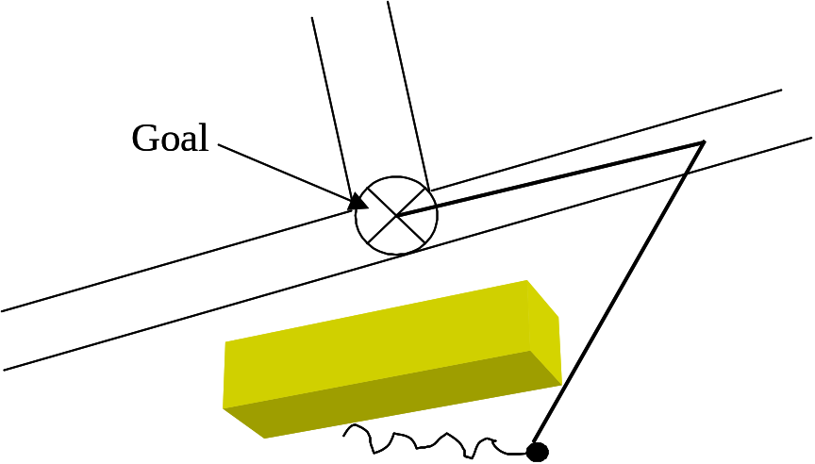
One taped measurement is made up to an intermediate point on the road and a compass bearing taken from the marker to this point. Next, another taped measurement is taken from the intermediate point to the goal and another compass bearing taken. Using this information, it is possible to use simple trigonometry to calculate the direct distance from the marker to the goal and the debriefers will be delighted to show you how this can be calculated!

Indirect measurement – GPS

GPS has now become an accepted form of measurement and is the preferred method for marker measurement if you are unable to measure directly, which also means more than 200m from the goal.

As with all forms of indirect measurement, this method will give us a co-ordinate for the marker rather than a distance from the marker to the goal.

The GPS system is very accurate, generally down to 3 metres on modern handheld units in open country, and triangulates from low earth orbit satellites although no-one has yet explained to me how the satellites know where they are!

Garmin have become the Nokia of the handheld GPS world, being easy to use and affordable. I use the GPS 12 model and would recommend it to any of you if you felt you wished to own your own unit. The cost is a little over £100 and one retailer is www.gps.co.uk another is www.gps4less.co.uk and it is normally worth checking www.globalpositioningsystems.co.uk The notes on operation of the unit and screen images are based on this model but will apply to most Garmin models and the principals will apply to all makes. Once the balloon has landed, you should also be able to use the GPS logger or even the pilots GPS.

Any GPS unit takes a few minutes to work out where it is when first switched on (a cold start) but will find your location much more quickly if it has been on recently (a warm start). For this reason I suggest switching your unit on for at least 5 minutes whilst in the open, prior to the flight. Allegedly, it can take a unit that amount of time to correct the displayed time and, as the time used for competitions is now GPS time, that may be important. Once your unit has settled down, you should set your watch to GPS time. Of course, if you are relying on your pilot’s unit, that will almost always be the flight unit and hence will have had sufficient time to settle down.

There are 5 standard ‘pages’ that the unit can display and you can cycle through these forwards or backwards using the ‘Page’ and ‘Quit’ keys respectively. The first page is the ‘satellite coverage’ page, which shows the satellites your unit is tracking and their signal strength and critically for us shows the EPE (estimated positional error) in the top right hand corner. For accurate readings, this should be 10 metres (30 feet) or less and in normal areas of good coverage, you should expect this to improve to about 3 metres (10 feet).
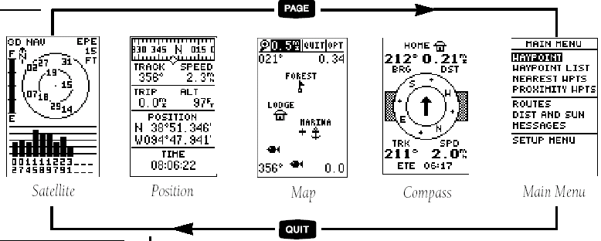

Once the unit has acquired what it thinks are sufficient satellites, it will automatically switch to the ‘position’ page with a linear compass at the top, some fields that can be changed by the user and critically for us, a position readout. The above image is from the manual and shows a latitude/longitude display, which is interesting but not much use for our purpose, we need Ordnance Survey information based on the British Grid, this is called the datum. Instructions on how to set/check this in a moment.

The position display on my unit reads:

TL 27275
BNG 14832

Of this, TL relates to the 100,000 metre grid square you are in – of little use to us, it is just how the ordnance survey system works. 27275 is the Easting component of the co-ordinate. BNG simply indicates that the unit is set to British Grid and 14832 is the Northing component of the co-ordinate. I will cover co-ordinates in a later section, but for now, you should understand that this is effectively a 10 figure grid reference with a resolution of 1 metre. We now record 10 figure references for GPS measurements (which would be 27275 14832) and the 2008 rules changed the accuracy of GPS measurements to 1 metre, so all 10 digits are required. Do not worry that the last digits will often jump by one or two units, even when you are standing still, as the 10 figures used will be an average.

The ‘map’ and ‘compass’ screens are of little use to us. This then takes us to the ‘main menu’ screen. For the moment, I will only cover the Setup menu and how to check or change some of the key settings.

Step by step, press the Page key until the Main Menu screen is displayed, then press the down triangle on the octagonal navigation key until the Setup menu is highlighted and now press the Enter key.

This will take you into a sub menu of which the first item is System, ensure that is highlighted and press Enter. The only item of interest is Offset which is the time difference to GMT, so we want this to be +01:00 for summer time and +00:00 for winter time. To change it, press the down triangle until that row is highlighted, press enter, then the right key to highlight the hour units, press the up or down keys until the display shows what you want and press the Enter key again. That has now been set. To get back up to the previous level, press the Quit key (if you press the Quit key repeatedly, you will get back to the familiar common screens at the top level).

The second item on this sub menu is Navigation and it is here that we can set our datum. If you are using the pilot’s GPS, this is where you can check and satisfy yourself that it has been set up correctly. The Position Format should be set to “British Grid” and the Map Datum should be set to “Ord Srvy GB”. If you need to change them, use the down key to select the appropriate field, then press the Enter key, use the up/down keys to change to the appropriate setting and press Enter to save that. It is possible for the unit to give plausible position information even if one of these is set incorrectly, but you will find that the given position is upwards of 50 metres out. If you have your own unit, you only need set this once, if you are using your pilot’s unit, it only takes a few second to check and will also impress you pilot that you know what you are on with, loggers will already be correctly set. Press the Quit key a few times until you get back to the position page.

That is all you need to know to competently operate a GPS for observer use.

Using the GPS to measure the marker, you must have had it on for at least 5 minutes before taking a reading, normally the time from walking from the car, finding and spraying the marker. Then you should complete the GPS section of the report sheet for that reading, the requirements may vary, but broadly, you should have an EPE of 10 metres or less, take three readings at 30 second intervals and if you find the reading fluctuating, take a further two readings. Do write down the full set of letter and numbers from the display, eg TL 27275 BNG 14832. You should still make a sketch of the position of the marker. If you have your own unit and know how to record the position at a waypoint, that is worth doing but if you don’t know how to do this, don’t worry. It is also sensible to verify that the co-ordinates that the GPS gives you look sensible when compared to the map – differences generally indicate that the incorrect datum is being used, see instructions above.

Now the really important bit. You should go to the goal and repeat the exercise! Having effectively left map measurement behind, we should be consistent in our measurement of both the marker and the goal and by measuring both in the same way with the same device, we should be able to calculate a very accurate measurement of the distance from the marker to the goal. Using this method, we are eventually working to an accuracy of 10 metres, so it is not necessary to work out the precise centre of the goal using the greatest circle method, but you should stand at your estimate of where that point would be. If the junction turns out to have a lot of traffic, DO NOT risk standing in the middle of the road to take your readings, it will be acceptable to take these from the side of the road, but try to stand exactly to either the North, South, East or West and make a note of both that and your estimate of the distance from that point to the centre of the goal.

If a common goal has been declared, especially if it is a target, the officials will normally take a GPS reading, so you will not need to repeat the exercise. If this is the case, it will be announced at briefing – if in doubt ask!

GPS loggers

We are now starting to use GPS loggers which are GPS units that can record the position and altitude of the balloon during the flight at 5 second intervals. That information is downloaded to a computer and used to judge PZ infringements, assist scoring of lost markers and can assist scoring explanations to pilots. In the UK, these will be as a supplementary aid for the scorers and competitions will continue to operate with observers as we know them. Internationally, this may extrapolate into some large competitions being run without observers but with a requirement for more officials with observer skills to mark goals and work in scoring/measuring teams.

We have selected a Garmin unit called the Geko 201. Despite the small size, this is a surprisingly capable unit although the more complex functions are not so readily accessible as it is a leisure orientated model, hence it is very easy to use!

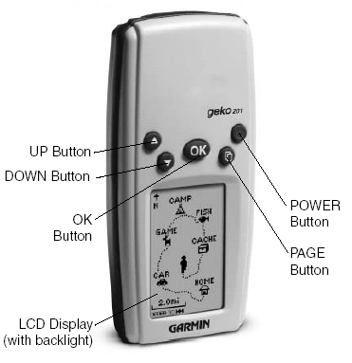
The Power button is slightly recessed and may need to be held for a couple of second to turn on and off.

As before, this unit has 5 standard ‘pages’ that the unit can display and you can cycle through these using the ‘Page’ key.

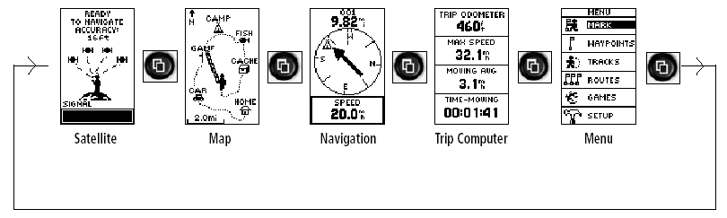
The first page is the ‘satellite coverage’ page, which should show a screen more like the image from the GPS 12, showing the satellites your unit is tracking and their signal strength and critically for us shows the EPE (estimated positional error) in the top right hand corner. For accurate readings, this should be 10 metres (30 feet) or less and in normal areas of good coverage, you should expect this to improve to about 3 metres (10 feet).

The ‘Map’ page is of no use to us.

On the Navigation page, it is possible to get the unit to show the co-ordinates with two presses of the Up key, but for some reason, the unit does not keep this setting, reverting to Speed as the default. Pressing the Up key three times will show you the GPS time and this appears to be the only place where the seconds can also be displayed. There are 5 possible display options here which you can cycle through with the Up and Down keys.

The ‘Trip Computer’ page shows 4 fields, each of which can be changed. For your purposes, one of these fields will show the location co-ordinates and one will show the GPS time, so this is the most useful page for you.

There is no need to enter any of the Menu options on the final page as the unit will have been correctly set up for you.

Using this unit for measuring markers and goals is as set out in the previous section.

Indirect measurement – pacing

In instances where direct measurement is not practical and GPS measurement is not possible, the old pace estimation method comes into its own. The situation will typically be that the nearest point on the map to which you can measure (typically a road junction) is not the goal, so we are back to estimating an 8 figure co-ordinate from the map and as such, our resolution is 10 metres.

To convert your paces to metres, we will calculate a pace factor at the beginning of the season and hope your legs don’t grow/shorten over the year. You should wear your boots and establish a comfortable pace that you will be able to consistently reproduce. When in the field, never allow another person to walk along with you, this may distort the length of your pace. Also, do not converse whilst pacing, it is all too easy to lose count.

You will need to determine how to work back from the features on the map to the position of the marker – you can only do this accurately by walking at right angles [or by resolving compass bearings]. In an ideal world, all roads are straight and you would pace from your marker at a perfect right angle to the road and would then pace along the road to the junction. You will then have two sets of paced distances which can be converted to metres at your pace factor and using the map, you can measure the appropriate number of metres from the junction along the road, then the number of metres into the field, mark that point and then estimate the 8 figure grid reference using your roamer. When measuring from map features such as roads or buildings, always measure to/from the centre.

The reality is an adaption of this theory to the situation you have in front of you. This is where a compass can come in handy, principally to note the bearing of the road at the point you leave it, so you can know the bearing which will be at right angles when you walk back from the marker.

As this method is clearly less accurate, it is even more important to make an accurate sketch map, to spray the marker and to note the relevant position of other markers dropped near your marker so the scorers can ensure the results come out in the right order for that task. In an ideal world, you should also pace in both directions and average the results.

Indirect measurement – trigonometry

This method is prone to more errors due to the complications, although the second method can be quite accurate if carried out correctly. As such is a bit of a last resort and should be backed up with the pace method, however, it has got me out of a difficult measuring situation more than once in the days before GPS use was accepted.

One method is to try to triangulate your position by taking bearing on landmarks you can identify on the map, of which the local village church spire is probably the best example. However, the bearings rarely meet at a single point, so this is true desperation time.

The better method is to walk a single or series of bearings from the marker to the map point you are going to use for measurement, ideally a road junction. By a little school room trigonometry, each bearing can be considered as a triangle relative to the North/South axis and the East/West axis and as such the distance you paced can be resolved into Northing and Easting components (not forgetting to adjust for magnetic North variation of course!). Done properly, this can actually result in a surprisingly accurate measurement, albeit with a page of calculations to back it up. If you need to use this method but don’t feel comfortable with the calculations, simply bring the notes of your measurements to debriefing and someone there should be able to help you work it out.

The good news is that GPS usage has negated the need for many of these indirect measurement methodologies.

Working out co-ordinates

As mentioned above, we work to an 8 figure grid reference with the Easting component (East to West) written before the Northing component. Each square shown on the 1:50,000 maps that we use measures 2cm on the map and represents 1 km on the ground. The numbers for each line of these squares is printed at the edge of the map and at intervals through the map. These numbers will immediately give you half the co-ordinates you need and it is then a question of using your roamer or ruler to estimate the remaining numbers – the last co-ordinate is really the only one where a certain amount of estimation is required. I have always found the most accurate method is to place the zero point of the roamer (the cross hairs or top right hand corner of the measuring grid) on the place to be measured and then to read the coordinates from the grid line under the roamer scale.

One of the golden rules of observing is that you should not assist the pilot with the completion of the tasks. This extends particularly to working out or verifying goal co-ordinates, this is the sole responsibility of the pilot. In the event of goal or provisional goal declarations on your observer sheet, ensure it is the pilot who writes down the co-ordinates.

If the pilot is working out their own goal co-ordinates, you should check these yourself and also note on your report sheet if the goal is invalid (it may be too close to power lines etc) but you should not point this out to the pilot prior to the flight. If the co-ordinates are ambiguous between two possible junctions within 200 metres, the least advantageous goal should be used for measurement (rule 12.3.2). If the co-ordinates the pilot gave you are slightly out, but the goal is obvious, it is normal practice to correct the goal co-ordinates on the report sheet and point this out at debriefing. This correction is especially important in the case of indirect measurement not using GPS.

Similarly, if you have measured the marker using GPS and then return to the goal to check the GPS co-ordinate of that, you should also correct the goal co-ordinates on the report sheet if necessary.

Leaving the pilot

Take the time to complete the form prior to going through it with the pilot. Ensure all the boxes are completed but if you did not observe a particular event, such as ‘time of marker drop’ do not fill in a time, simply write ‘did not observe’.

The report form has a box by each marker drop for ‘Observer’s estimated result’ – this is an important logic check used by the scorer to ensure that the result calculated by the scoring program is not wildly different from your estimate. This should not be calculated precisely on a calculator (that is what the scoring program is for), but measured roughly from the map using a ruler or roamer.

You should encourage the pilot to go through all entries on the report form with you and when you are both satisfied, you should both sign the form. Once the form has been signed, no changes should be made. If you notice an omission during debriefing, point it out to the debriefer who will then add it to the form.

In the event of disagreement, do not feel under pressure to change your report (unless you agree with the change) but note the comments for debriefing.

There should be no surprises for the pilot when he sees the results. Whilst it is fairly common for minor corrections to be made during debriefing, you should tell the pilot of any infringements that you are planning to report at debriefing.

Observer Logbook

It is worthwhile getting a logbook from the Chief Observer to record all your observing, and will be useful as evidence of your experience if you would like to qualify for International Observing. Find time to fill in the details, and ask the pilot to sign it at the same time as they sign off the Report Sheet.

Debriefing

There is no mysticism to debriefing, this is simply an independent check of your entries in preparation for scoring. This is also an opportunity for you to discuss any difficulties you had or to ask for advice.

Debriefers are looking for the following key information:

- Completion of all times – to enable them to check time limits in the rules
- Clear and sufficiently detailed sketch maps – so an official could find the marker in your absence
- Consistency in measurement method – using GPS for both the marker and the goal and not mixing GPS and map measurement on the same task
- Goal co-ordinate checks (esp for PDG and Fly-On) – to ensure the distance limits are OK and the goal is valid and unambiguous
- For a Fly On, co-ordinates on the marker tail – to ensure there are no more than permitted and to check the goals are valid

Sometime there is a formal system of registering that you are ready to be debriefed, so that you stick to a proper order, but at smaller event this is worked out informally by the observers waiting.

At the end of your debriefing, get your logbook countersigned by the debriefer.

The tasks – including key points for observers

For all tasks

Check minimum and maximum distances per the task sheet.
Check for infringements – the list on the report form is a good starting point but is not necessarily exhaustive, you should read and understand the rules.

Pilot declared goal (15.1)

Competitors will attempt to drop a marker close to a goal selected and declared by him before flight. The result is the distance from the mark to nearest valid declared goal. Smallest result is best.

Key points

Check that the goal is valid and unambiguous.
Correct goal co-ordinates if only very slightly out.

Judge declared goal (15.2)

Competitors will attempt to drop a marker close to a set goal. The result is the distance from the mark to the target, if displayed, or goal. Smallest result is best.

Hesitation Waltz (15.3)

Competitors will attempt to drop a marker close to one of several set goals. The result is the distance from the mark to the nearest target, if displayed, or goal. Smallest result is best.  Key points  Calculate which is the nearest goal, especially as this may affect distance checks. | 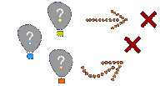

Fly in (15.4)

Competitors will find their own launch areas and attempt to drop a marker close to a set goal or target. The result is the distance from the mark to the target, if displayed, or goal. Smallest result is best  Key points | 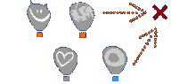
Check launch times.
Check launch position and if you think this is close to the minimum or maximum distance, measure it as if it were a marker drop.
You should ideally witness obtaining permission to launch from that location if it appears to be private property.

Fly on (15.5)

Competitors will attempt to drop a marker close to a goal selected and declared by them during flight. The result is the distance from the mark to the nearest valid declared goal. Smallest result is best.

The competitor shall write clearly on the previous marker his declared goal for fly on. If the previous marker is not dropped or no goal is written on the marker the competitor will not achieve a result.

Key points

If you are flying, rule 15.5.5 says that you should witness and record the co-ordinates written on the previous marker before it is released.
Note the co-ordinates on the previous marker and check the goal as for the Pilot declared goal.
If you are returning to measure the marker later, note the co-ordinates as soon as you first find the marker.
Ensure other co-ordinates on the previous marker have been crossed out – unless more than one goal is permitted, they will be measured to their worst ‘goal’.

Gordon Bennett Memorial (15.8)

Competitors will attempt to drop a marker within a scoring area(s) close to a set goal.

Key points

Be aware that the ‘goal’ will not normally be in the scoring area(s).
Listen out for the definition of the edge of the scoring area during the briefing (often this is the inner edge of the road surface such that the road surface itself is outside the area).
If the marker is dropped outside the scoring area, there is no need to measure it as long as the pilot agrees. In case of uncertainty, measure as normal.

Elbow (15.11) and Land run (15.12) and Angle (15.19)

Elbow: Competitors will attempt to achieve the greatest change of direction in flight. The result is 180 degrees minus the angle ABC. Greatest result is best. | 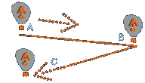
Land run: Competitors will attempt to achieve the greatest area of a triangle "A", "B" and "C". The result is the area of triangle ABC. Greatest result is best. | 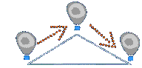
Angle: Competitors will attempt to achieve the greatest change of direction from a set direction. The change of direction is the angle between the set direction and line "A-B". The result is the angle between the set direction and line "A-B". Greatest result is best. | 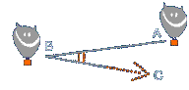
Key points

The requirement is for co-ordinates for each marker, so they must all be measured by an indirect method.
Be aware that some of the markers may be used to also score other tasks on the same flight and as such, you may need to measure the same marker in different ways for the different tasks.

Minimum distance (15.13)

Competitors will attempt to drop a marker close to the common launch point, after flying a minimum set time. The result is the distance from the mark to the launch point. Smallest result is best.

Key points

This tasks probably has the best chance that the pilot will opt to fly you to minimise the risk of losing the marker or not seeing the marker drop within the time allowed.
Be very aware of the times, the time limit for each pilot will normally start when the launchmaster confirms that your balloon has taken off.
Be aware of the ‘clearing the launch area rule’.
You will almost certainly have an indirect measure from an inconvenient location.

Minimum distance double drop (15.15) and Maximum distance double drop (15.18)

Competitors will attempt to drop two markers in different scoring areas.

Key points

Listen out for the definition of the edge of the scoring area during the briefing (often this is the inner edge of the road surface such that the road surface itself is outside the area).
Unless it is feasible to directly measure between the two markers, you will need to measure each by an indirect method so you can establish the co-ordinates of each marker.

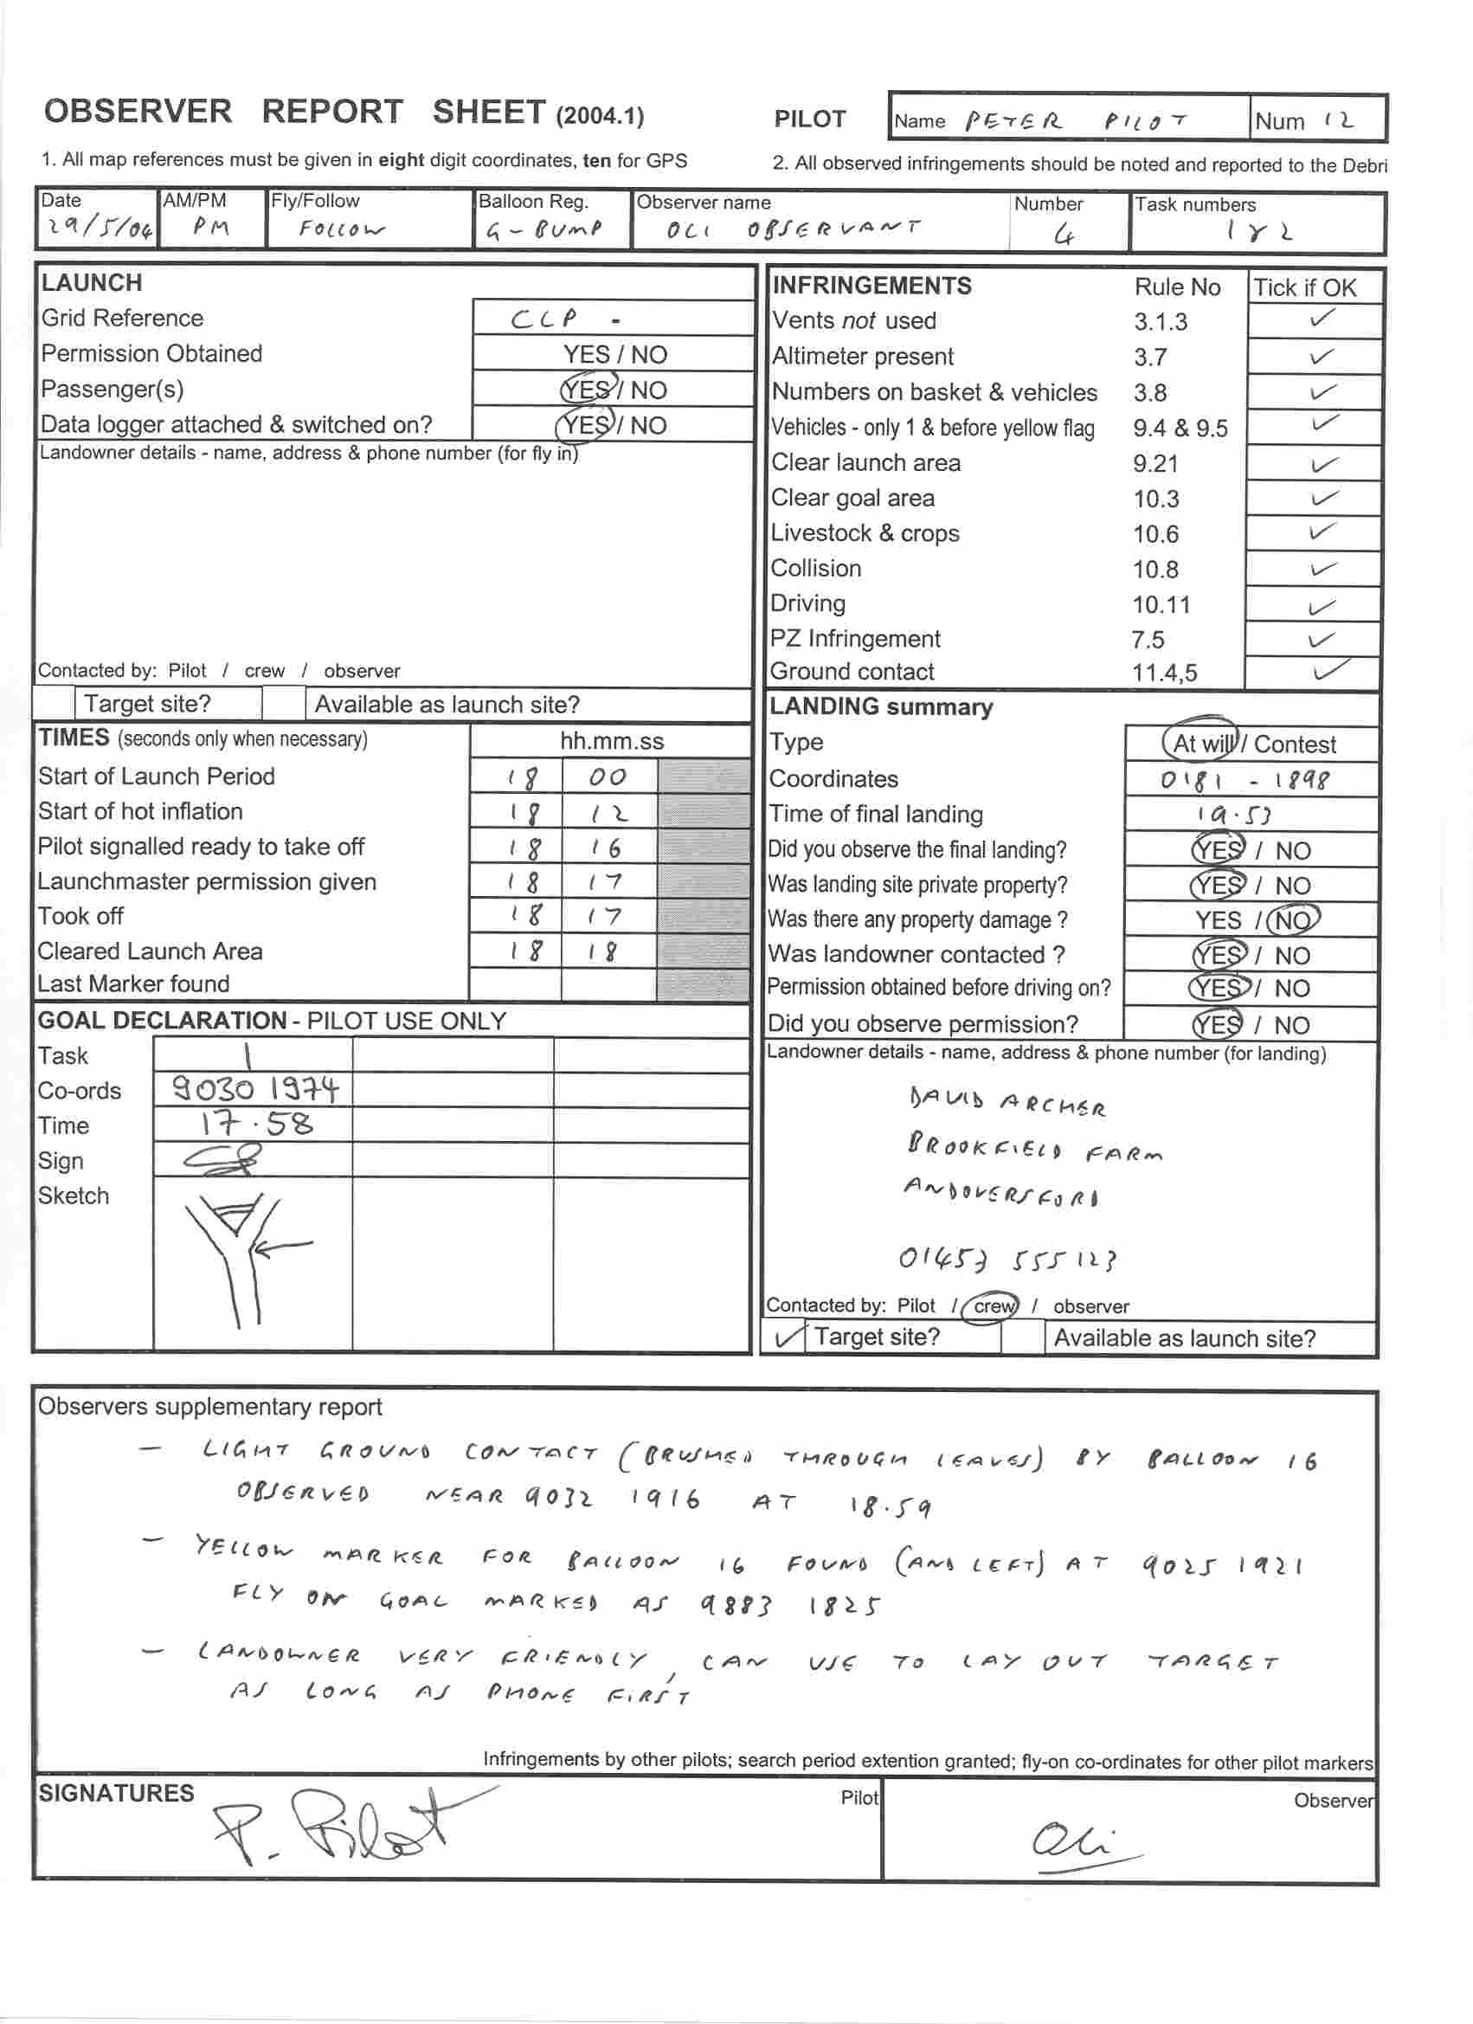
Appendix I - Sample observer report sheet

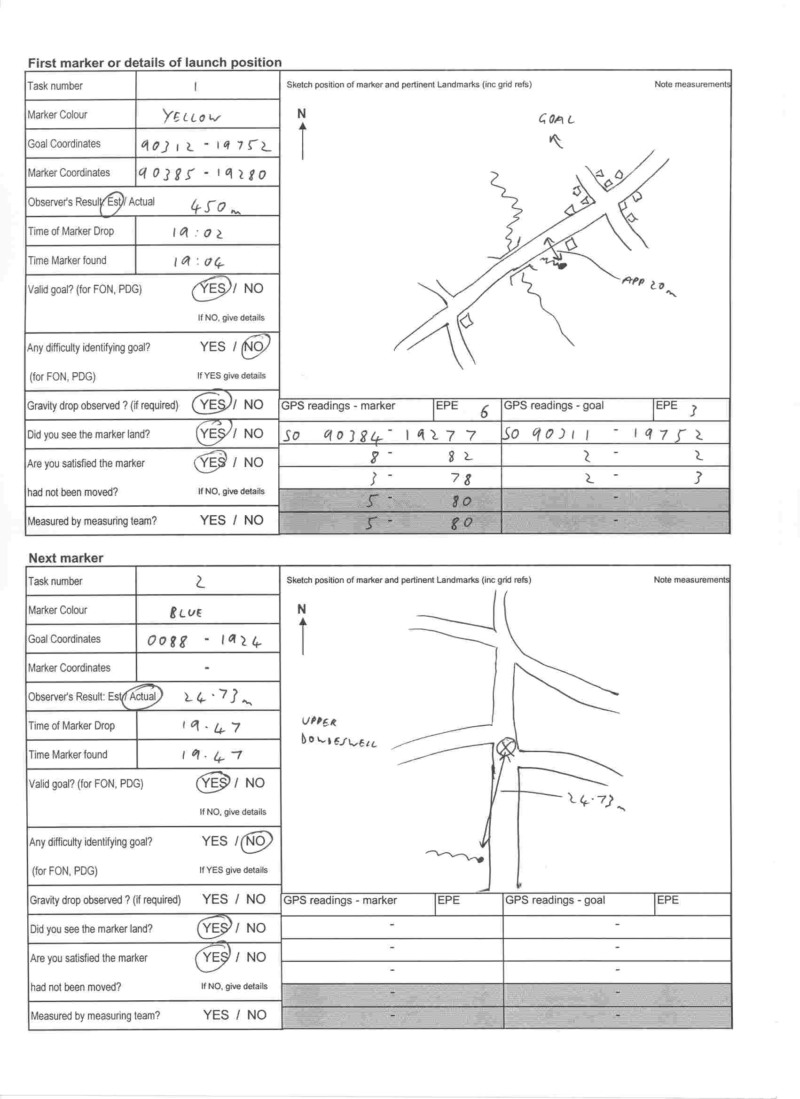

Appendix II - Guidelines for Observer Development and Selection

There are 3 Levels of Observer.
- Novice Observer (Obs/N)
- British Observer (Obs/B)
- British International Observer (Obs/I)

Promotion from one level to the next is according to the following procedure.

1. Novice Observer to British Observer
To qualify as a British Observer, the Novice Observer must:
- Be of British nationality. (British means holder of a current British passport, or subject to the definition in the Sporting Code section 3.1.4)
- Be a member of the BBAC Competitions Club, and
- Have experienced a minimum of 5 different competition tasks during a Grand Prix/National Season.
These 5 tasks must include two of the following:
- Elbow or Angle
- Minimum Distance
- Maximum Distance
- Gordon Bennett.
These must also include a minimum of 2 multiple task flights.
This experience is ideally recorded in an Observer Logbook.

2. British Observer to British International Observer
To qualify as a British International Observer, the Observer must
- Be of British nationality (see above)
- Be a member of the BBAC Competitions Club, and
- Have logged experienced across an additional 8 tasks, including multiple task flights over the preceding 3-year period (i.e. in addition to the tasks completed to achieve British Observer Status). This experience may be gained across British or non-British competition. The Chief Observer may make reference to the Chief Observer (or other Official) of a non-British event to assess the quality of that experience.
It is acknowledged that the qualification for International Observer status is under regular review within the CIA Observer Commission, and this may affect British selection procedures. Currently British International Status is determined separately to the CIA International Observer Scheme.

Annual Assessment
A brief assessment will be made at the end of each season to review the status of individual Observers. The assessment will be made by the Chief Observer, in consultation with a minimum of two Competition Officials (Debriefers or Directors), all of who must be current members of the Competitions Club. Observers may see their assessments on request.
The result of the assessment will be subject to the approval of the Competitions Club Committee.

Any Observer wishing to be considered for a higher category for the next year should apply to the Chief Observer by the end of October, ideally sending his or her Logbook as evidence in support of the application.

The Chief Observer may also in exceptional circumstances and after consultation with a minimum of two Competition Officials (as detailed above) and if appropriate International Officials, recommend to the Competitions Club Committee that an Observer be downgraded.

British International Observers who have not officiated at National or International events for five years will be included in the register of British Observers.

Selection for Category 1 events.
According to the Sporting Code, an Observer must be sanctioned by his/her NAC in order to be nominated for a Category 1 event.

Observers of International Observer status will be eligible for Category 1 events for a period of one year from January 1st. The order in which places at Category 1 events are offered shall be determined by a draw that will take place at the beginning of the calendar year at the AGM, or the first committee meeting of the year. Observers wishing to take part in the draw should inform the Chief Observer by January 1st, or by the AGM, whichever is the earlier.

The Chief Observer will not take part in the draw, but will automatically be given first choice of the event he or she wishes to attend that year.

To take part in the International Draw observers should be members of the Comps Club. The Draw shall be made in three divisions in the following order:
- Qualified Observers who have observed or officiated at either the British Nationals, or two Grand Prix, the previous year, but who (having taken part in the observer draw) have not been offered the opportunity to observe at an International meet that year.
- Other Qualified Observers who have observed or officiated at either the British Nationals, or two Grand Prix, the previous year.
- Other Qualified Observers.

Observers from divisions 1 or 2 who accept ‘direct offers’ of places from the Chief Observer of any Category 1 event, will be placed at the end of the list of Observers for division 2 above, for selection for any further events.

The phrase ‘observed or officiated’ at a competition refers to those occasions when the observer attended, whether there was any competition flying or not.

January 2003

