Easyfundraising

Thank you for demonstrating an interest in helping Carmel & District Cricket Club raise vital funds towards a new club net facility up at the ground. As part of our fundraising attempts, we have set up an Easyfundraising page – which offers a cashback service on online purchases from selected retailers e.g amazon, booking.com, trainline, M&S etc etc etc.

Simply shop through the easyfundraising webpage and raise money for the club – there are no extra costs/ hidden charges for the purchaser!

Below, is a step-by-guide, which we hope will assist club players, family members and friends sign-up and start raising funds today..
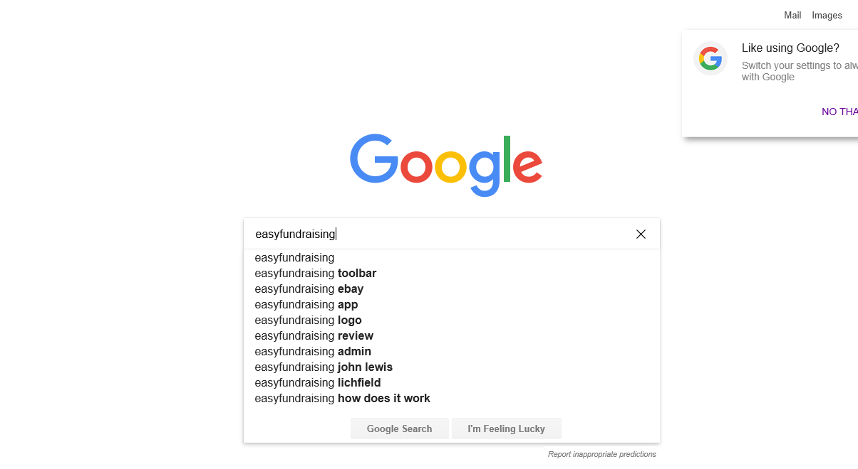
Type 'easyfundraising' into your preferred internet search provider

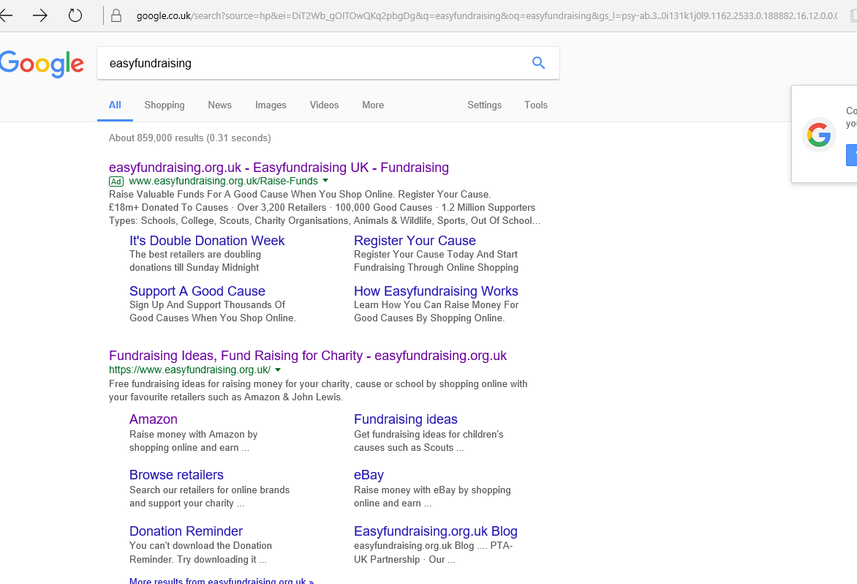
Click on the top search result (https://www.easyfundraising.org.uk/panel/)

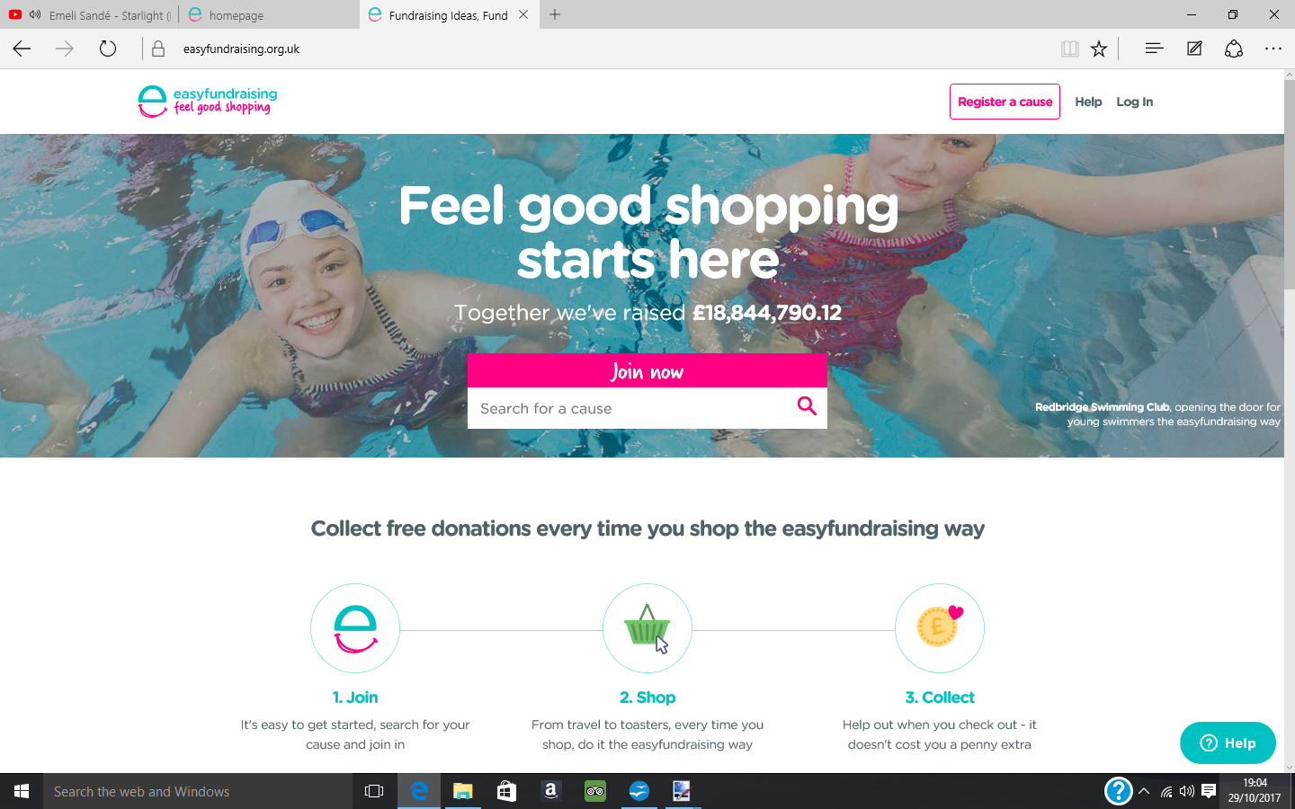
In the 'Search for a cause' box, type 'Carmel & District Cricket Club'

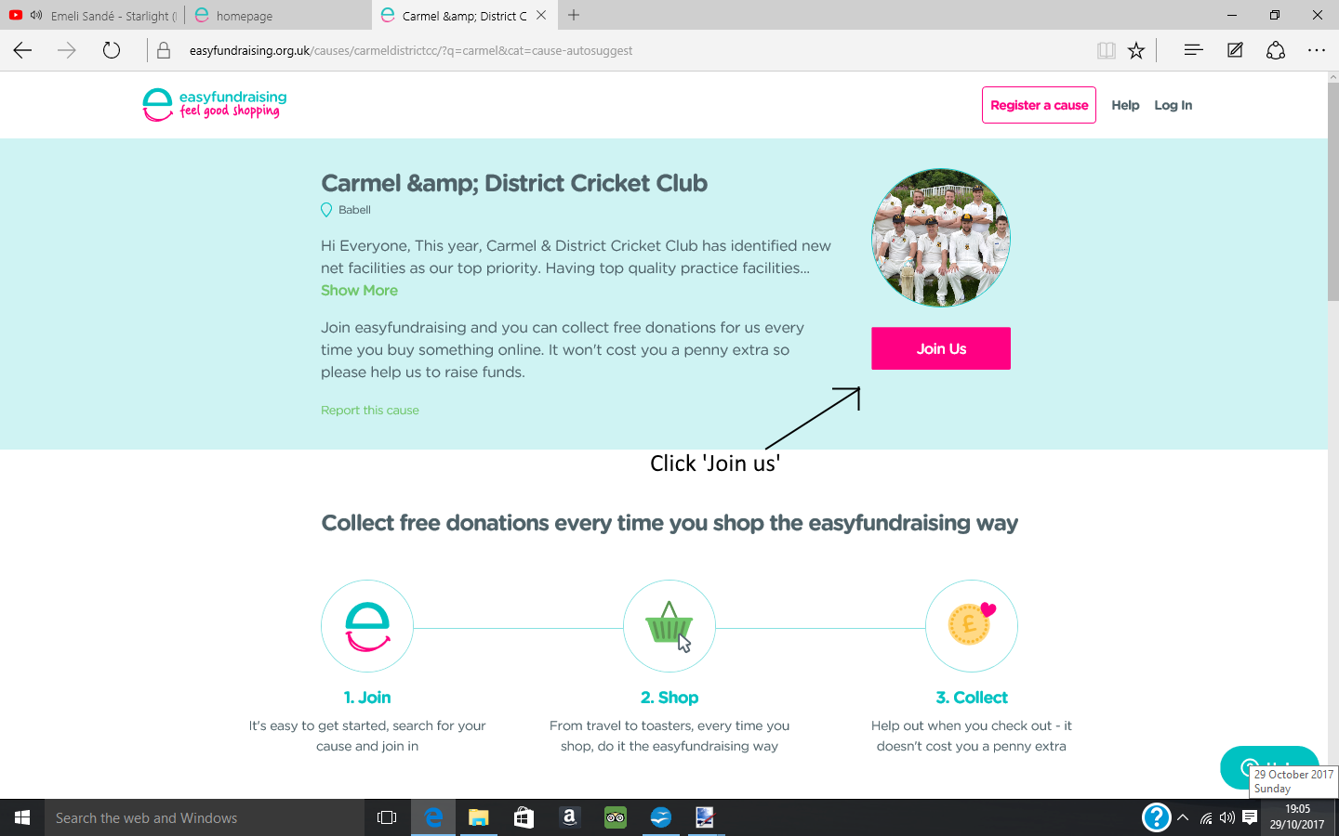
Click 'Join us'

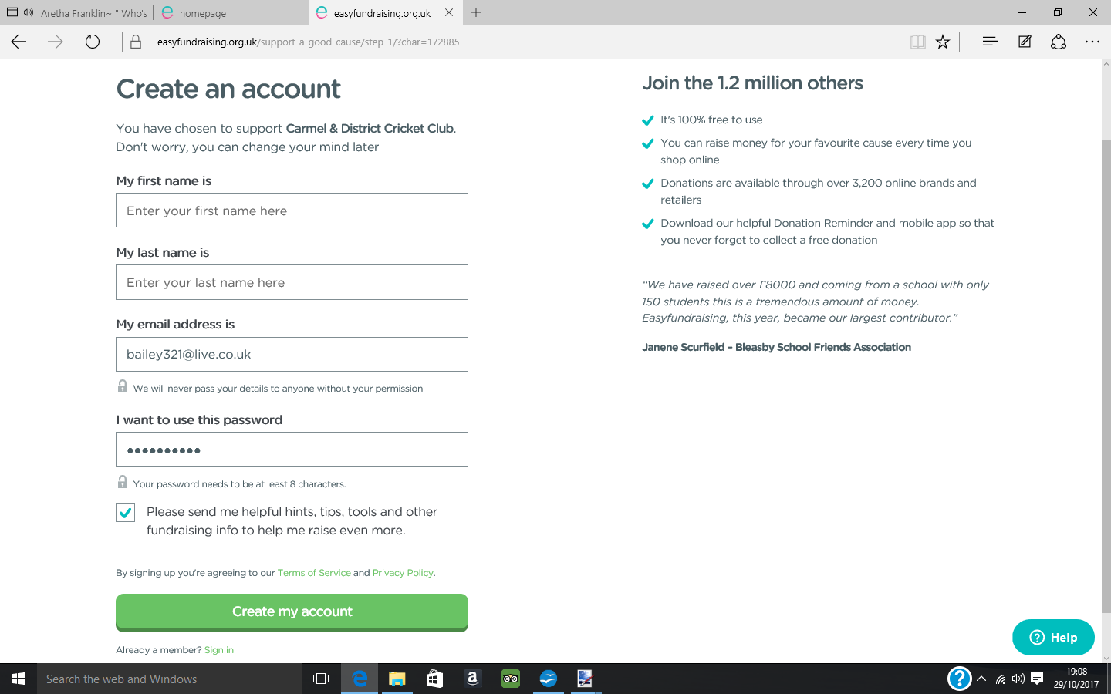
Enter your details in the boxes to create a new account.

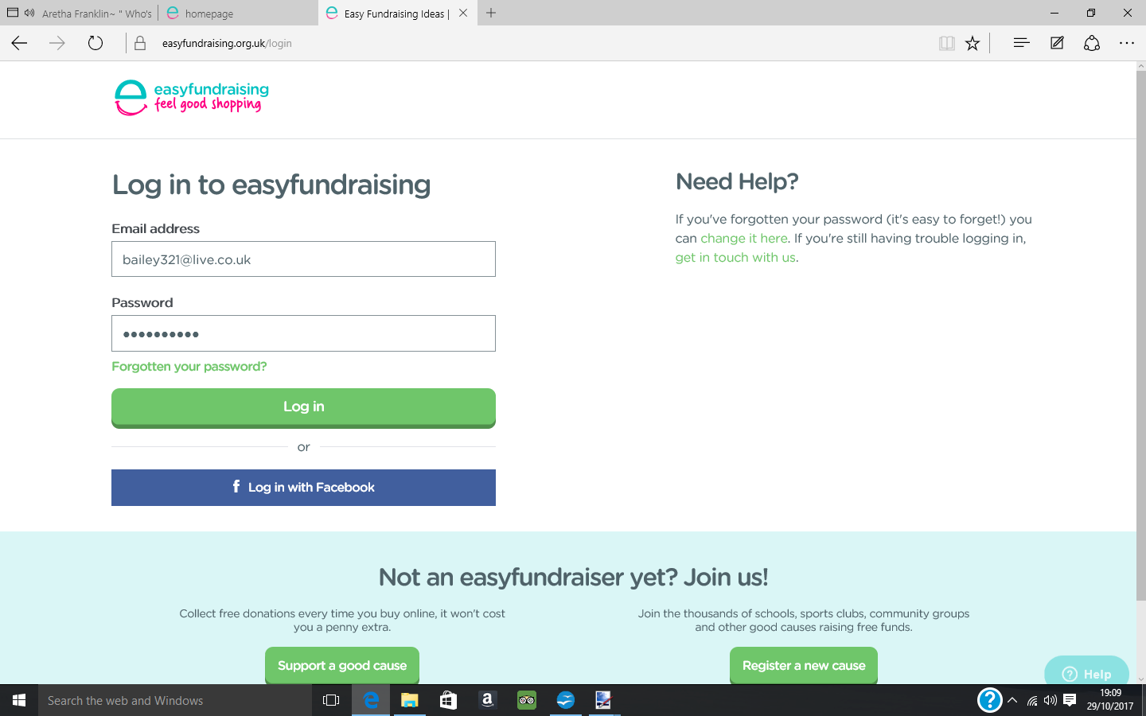
Once you've created an account, sign in.

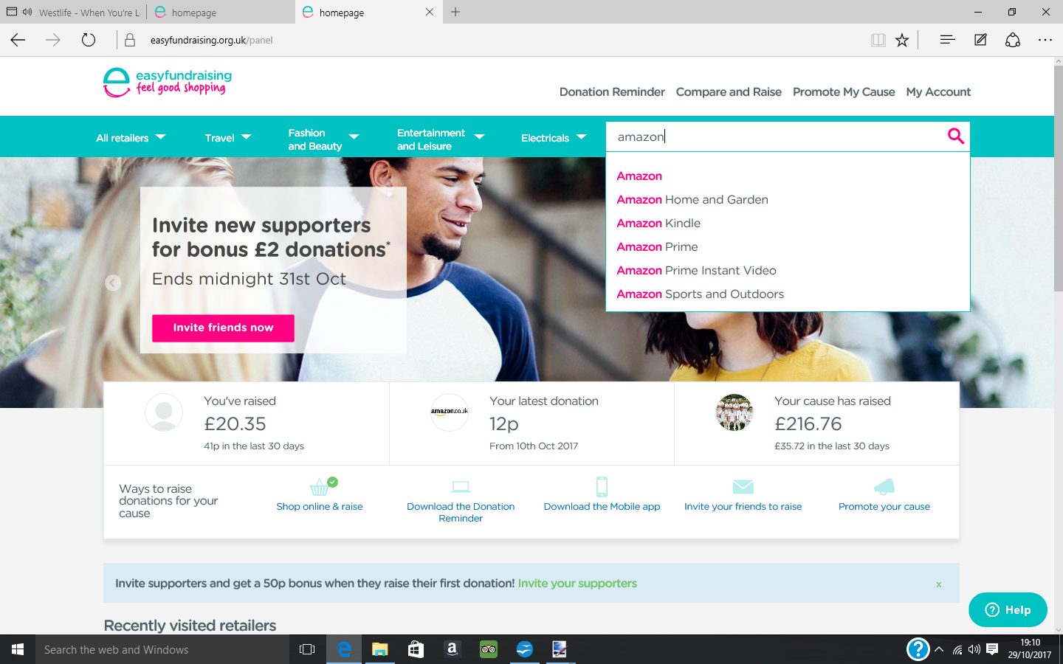
Congratulations! You are now ready to shop and raise money for the club. Type your preferred retailer into the search bar at the top of the screen e.g Amazon

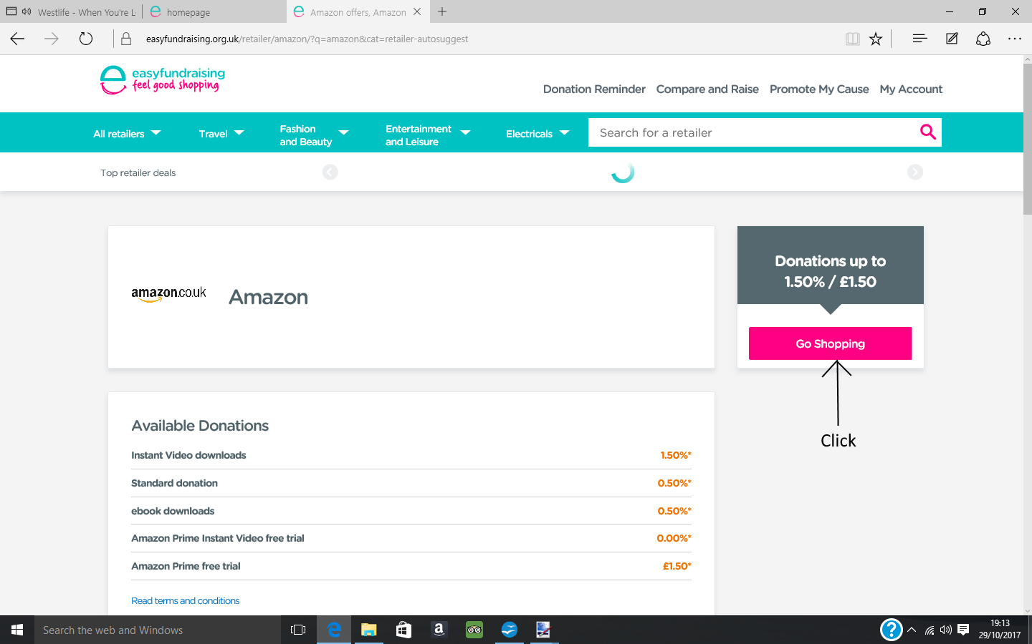
Click 'Go Shopping'

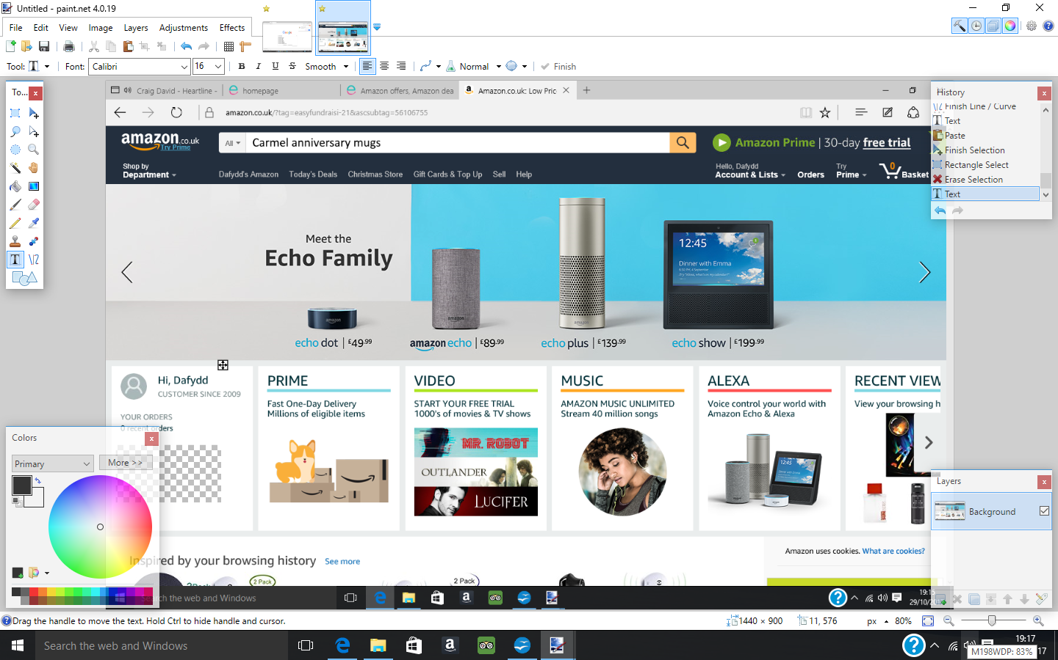
Shop as normal and collect free money for the club. (No need to tick any boxes at checkout).

Usually after a couple of days, you will receive an e-mail to confirm your donation (and amount) for the club

If you would like to keep a track of all your donations, you can go to the 'My account' area of the wesbite and see all previous donations and how the club is getting on as a whole.



