Hesketh Bank
Association Football Club
www.heskethbankafc.co.uk

Full Members of the Lancashire Football Association Members of: The West Lancashire League,
Lancashire Sunday League, Mid Lancashire League, Central Lancashire Junior League & Mid Lancashire Colts Junior League

Chairman & General Secretary: Paul Sergeant, 108 Moss Lane, Hesketh Bank, Preston PR4 6AD.
Telephone: 01772 814009, Mobile: 07713158393. Email: paul.sergeant@btconnect.com

APPLICATION FORM

5-A-SIDE THURSDAY NIGHT
SUMMER FOOTBALL LEAGUE 2016
AT HESKETH BANK 3G PITCHES

Team Name: ………………………………………………………………………………………………….

Team Contact Details: Name: ………………………………………………………………………………

Address: ……………………………………………………………………………………………………….

…………………………………………………………………………………………………………………..

Mobile No: ……………………………… Email Address: ………………………………………...............

Alternative Contact: Name: ………………………………………. Mobile No: …………………………

As a nominated contact I agree that my team and players will abide by the competition rules & regulations and are aware that the league will be affiliated as a Small Sided League with the Lancashire Football Association and as such all teams who enter and their players will be subjected to the disciplinary process of the County FA. Matches will be officiated by FA Qualified Referees and will also be covered by Public Liability Insurance.

Signed: …………………………………………………………….. Date: ………………………………….

Main Club Sponsor
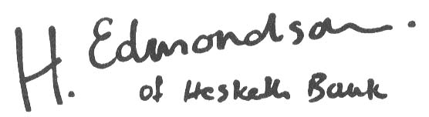

Main Pitch: Centenary Sports Ground, Station Road, Hesketh Bank, Nr Preston PR4 6SR
Other Grounds: Shore Road & Guide Road, Hesketh Bank, Nr. Preston, Lancashire
Established 1922

