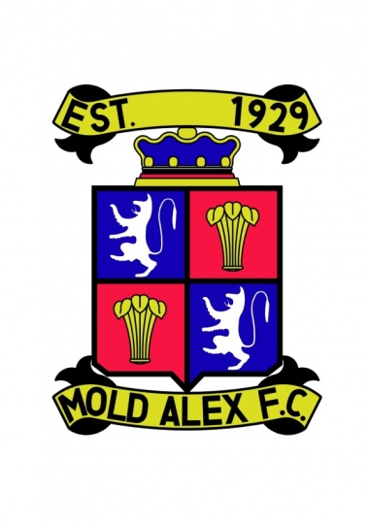
Mold Alex

Vets Over 35s 6 a-side Football Tournament
Cathy Griffiths Memorial Cup
Venue: Alyn Park
Date: Saturday 16th June

This tournament is based on two groups of six. This means it will give every team at least five 20 minute games.
At the end of the group stages the top two in each group play in the knockout rounds, semi final and then final.
It is a 6 a side tournament with each team having a maximum of 10 players in the team squad.

All players must be at least 35 years or over i.e. vets league rules

All teams are allowed one underage player between the age of 30 and 35.
Maximum of 2 teams per club
All teams must provide their own insurance and first aid
Fee £40 per team. Please make cheques payable to Mold Alex F.C

Please returns form ASAP as we are only accepting 12 teams on a first come first served basis
All forms returned to
Andrew Roberts
40 Dreflan
Mold
CH7 1DF

Name of Team/Teams
Contact Name &
Address
Contact Email Address
Contact Phone number

Tournament Organizer

Andy Roberts
07748246277
Andydreflan@aol.com

