# Minutes of Petersfield RFC AGM

# Held on 8th May 2018 at PRFC clubhouse.

There were 36 club members present. (39 last year)

# Apologies for absence.

There were a number of apologies for absence from club members and VPs. The only officer who apologised for his absence was the treasurer, Andrew Willson.

# Minutes of previous AGM:

These had previously been circulated to all attendees and posted on the website

# Matters arising;

There were no matters arising.

# Chairman’s report (Stuart Barden)

1st XV – Maintained their LSW-3 League Position  
2nd XV – 7th Solent League 2  
3rd XV – Winners Solent League 4  
Vets – 3 Games – Won 2 lost 1  
Colts – 3rd Hampshire Colts League 2  
U16’s – 4th Hampshire League 1  
U15’s – 4th Hampshire League 2  
U14’s – 3rd Place Hampshire Plate Competition  
U13’s – Knocked out in early Round of Hampshire Cup   
U7-U12’s – great season from all ages – with record numbers of players

* 1. **The club successfully installed its new gym and seating area.**

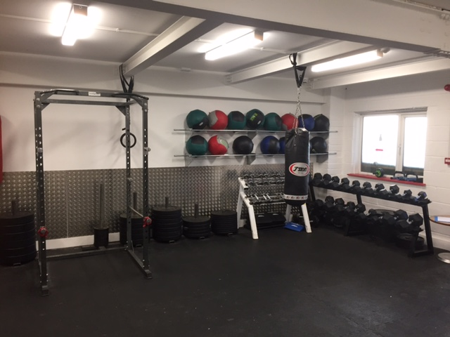

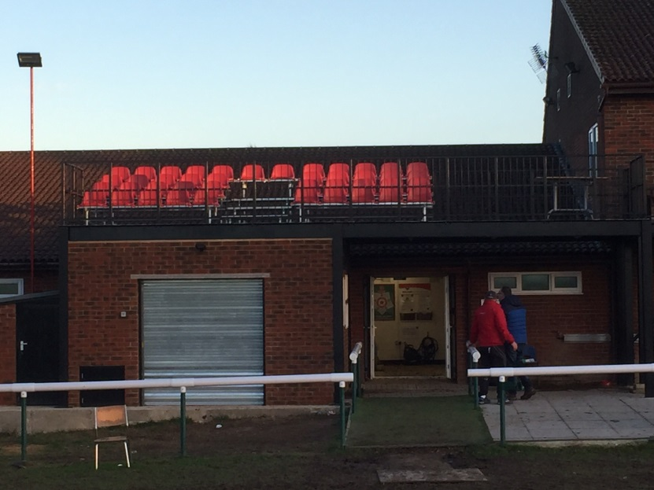

* 1. **Achievements**
* EHDC Sports Winners – Team, Club & Coach
* Fundraising for Good Causes RN Match, HFRS Match, Yomp
* Music Field
  1. **The Next Phase of Club Development**

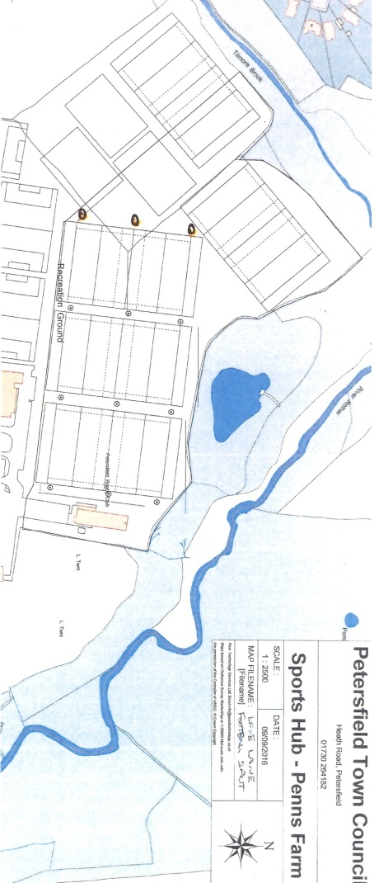

* 1. **Very successful overseas tour to Flers for 3 teams, coaches & parents**
  2. **NatWest Rugby Force day: Sunday 24th June**

# Secretary’s report (Rob Mocatta)

# Club administration

* Operating committee met 10 times, Average attendance was 10 people

# Club communication

* PRFC continuing strong social media presence . Thanks again to Paul Harrington for running it
* Club website **(www.pitchero.com/clubs/petersfield )** also thriving. Teams are encouraged to submit text to Paul Harrigton.

# International tickets

The club managed to get 277 Twickenham tickets for its club members.

# Discipline

* No players red carded this season. Well done.
* Club coach James Alder was banned for 2 months for abuse of officials. The club is working with James to resolve this issue.

# Touch rugby

* PRFC ran “turn up and touch” all summer. Again very successful
* Many thanks to Gerry Devlin for running it.

# Treasurer’s report (Andrew Willson)

These are preliminary figures. The full figures are available to any member who wishes to see them.



# 





# Motion to approve draft 2018 accounts without Formal Audit

This was proposed and seconded and unanimously approved

# Election of officers

The President, and Secretary were re-elected. The treasuer, Andrew Willson, stood down. He will be replaced by Dave Auger. The Chairman was re-elected by the other officers.

# Election of Vice Presidents

There were no new VPs nominated this season.

# Awards presentations:

* + 1. **Chairman’s thanks**

Stuart Barden thanked all the people involved in the running of the club. He particularly thanked Wendy Wilson for running the clubhouse, Jo Sims for taking over the clubhouse, Sara Bambrough Smith for running the shop, Grant Wilson for his efforts with the minis and juniors, James Blumlein for Membership, Ruth Chinnock for her physio support, and Megan Millar for her safeguarding work.

* + 1. **Andy Millar Shield**

This was awarded to Russell King

# Audit of accounts

The members present agreed unanimously to opt out of an audit, in line with the previous year. This followed the advice of the treasurer and the secretary.

# Any other business

There was a discussion of fees. The AGM decided to maintain the fees at £100.