Finals Day

Help Us This Year to Deliver Sport to Young People!

A Word from our Chair

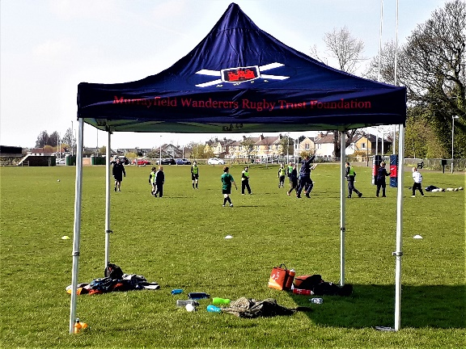

The Trust Gazebo

2018 was a pivotal year for the club with the relocation to Roseburn Park and use of the facilities at Murrayfield Ice Rink. Despite these challenges both the club and the Trust have overcome these obstacles to maintain momentum in a difficult period for Scottish club rugby.

Murray Hastie has been at the forefront of promoting rugby within the local community and he and his team have been a tower of strength in encouraging kids to participate in the sport. The Trust has made strenuous efforts to support his work and provide funds. We have purchased a Gazebo to provide much needed shelter for parents and participants when conditions are inclement, as well as T shirts and gum shields. In addition, Murray has run some excellent and enjoyable fund raising nights to which the Trust has donated prizes.

The current Easter Camp has been attended by forty five children and we would love to increase Murray’s team next year to develop a bigger player pool to participate in tournaments. To do so, we need to generate more funds and this is where we need your help. At the end of this Newsletter is a Gift Aid form. Any donation, however small, will help us achieve our objectives.

Please give generously – the next generation is relying on us!

Andrew Jones (Chair)
aj@lomondadventures.com

Three Good Reasons to Support the Trust:
- Wellbeing
Health Education Board Teen Anti-Smoking Campaign
Having spent my career in health marketing and later in youth rehabilitation, I have no doubt that sport has a vital role to play in helping Scotland’s next generation achieve their full potential. Too long has Scotland languished at the bottom of European health leagues and sporting participation has been proven to improve life expectancy and mental health, while reducing the likelihood of offending. Our work has been incremental in developing opportunities for participation for those who might not otherwise become involved.

A recent survey by the University of Alberta has shown that organised sport has greatly reduced behavioral problems and ADHD in children. The reduction of computer and TV screen time has clear benefits for the mental and physical health of our children.

- Lifelong friendships
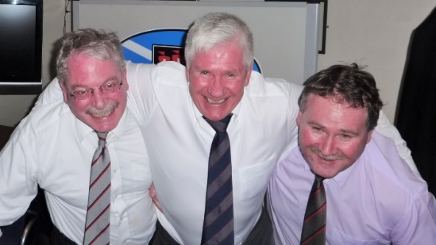
The Front Row Reunite!
When I first joined the club I was new to Edinburgh and knew no one. The attraction of Wanderers was that it was an open club with members from a wide variety of backgrounds. Thirty five years later, despite having spent a long time living on the West Coast I was able to assimilate back into the club as though I’d never been away. Friendships developed through rugby last for life and, although we may advance in years physically our memories never fade, as last year’s highly successful 150th anniversary dinner demonstrated.

- Fun and Games!
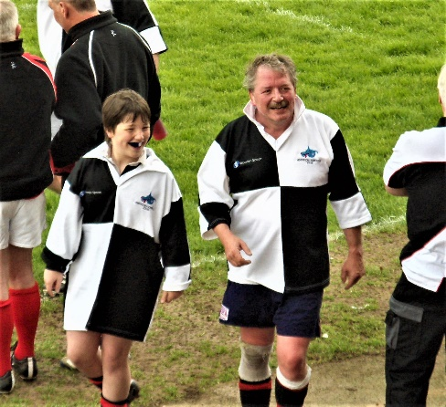
The Tweedie Fun Run The Generations Collide
Murrayfield Wanderers have successfully relocated to Roseburn Park and have exciting plans to build resources at its new home. The success of these measures is vital, not only for us but for club rugby as a whole. In recent years, Scotland’s playing numbers have fallen away due to the lure of video games and lack of investment.

However, the development of our community club has benefits, not only for the next generation to play for Scotland but for society as a whole.
In the recent past we have organised a Stroke Association Fun Run for our club legend, David Tweedie as well as an intergenerational fun match which gave fathers an opportunity to show their offspring a trick or two. Watch out for our Development team’s social media feeds to get involved in Festivals, auction nights, touch rugby and more.

Development Team update

It’s been a fantastic year so far for Murrayfield Wanderers FC development team, gratefully supported by Murrayfield Wanderers Rugby Trust Foundation. This year I have been supported by two sessional coaches: Nathan Smith and Sula Callender. Both have an interest in coaching and have delivered numerous sessions to hundreds of children across our cluster schools.

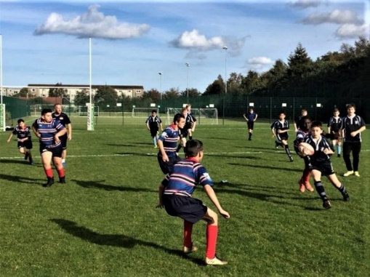
Under 14s and Tyne Girls
Tynecastle High School and Wester Hailes Education Centre (WHEC) continue to combine to represent Murrayfield Wanderers FC. Together they take part in rugby festivals across the city and play in the Edinburgh Rugby Tier 4 Developing and Emerging schools league. This league gives us a pathway for pupils to represent the club and play in competitive contact matches. We have had a total of 20 pupils play contact rugby for the very first time this season.

We continue to run curricular and extracurricular sessions within our cluster primary and secondary schools. We have delivered rugby to a total of 11 primary schools including 230 curricular sessions since September 2018, working with P3 through to P7 pupils. We continue to work in partnership with WHEC to run a School of Rugby programme for S2/S3 pupils, delivering two curricular sessions a week to a group of 12 pupils throughout the school year. In addition, we run several after school, lunch time and morning clubs within our clusters. These sessions give pupils a pathway to continue and give us an opportunity to promote our mini/girls rugby sessions down at the club.

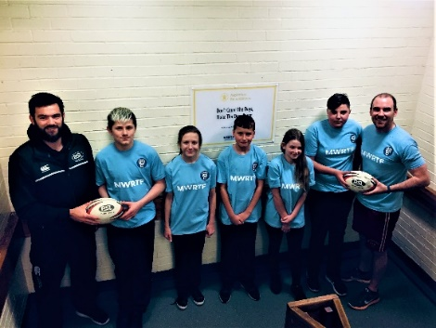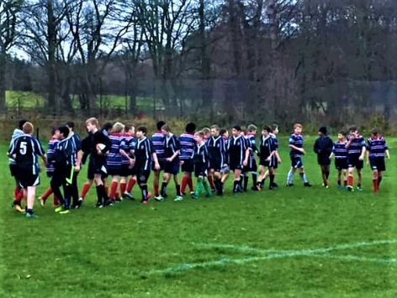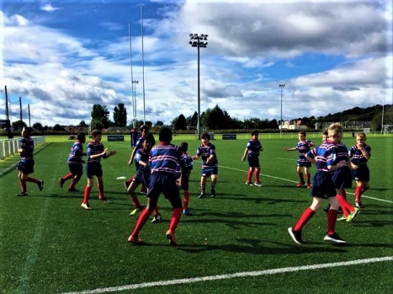
Leaders
I have also delivered a ‘Startrugby’ course to Sport Leaders at both Tynecastle High and WHEC. The course consists of pupils learning about the principles of play, rugby values, delivery styles and mind set growth. Pupils also have the opportunity to plan and deliver a session to a group of primary school pupils, which is not only a great way for them to learn more about rugby, they also get the chance to give something back to their local community.

Within the club, the development team continue support both our mini and girls sections by assisting club coaches during sessions throughout the year. Additionally, we provide coaches with opportunities to develop by encouraging them to attend CPD workshops or gain coaching qualifications.

In my opinion, rugby is a sport that can be enjoyed and played by all people, regardless of age, gender, race, or athletic ability. It can develop self-esteem, confidence, and social skills and teach valuable life lessons along the way. Murrayfield Wanderers FC development team will continue to develop rugby throughout the local community. We intend to do so by promoting rugby values, encouraging boys and girls to play the sport within their schools and providing them with a pathway to play for the club.

Murray Hastie
Murrayfield Wanderers FC Club/Community Development Officer
murrayfieldwanderersdo@hotmail.com
https://www.facebook.com/Murrayfieldwanderers/, https://twitter.com/wandiesrugby

Our Venerable Consultant Mike Dawson writes:

Achieve happiness, enjoyment and participation from losing and from winning! Not everyone can come first, but we are all are winners in the end.

Virtually all our boys and girls in Primary, Secondary or Special Needs schools that our Rugby Development Team visit, are State schools and are new to the rugby family and the supporting way of life. The focus of our work is in having fun and friendship, sharing in the benefits of team activity, a healthy life style and well-being, regardless of whether our charges are winning or losing. Generally, there is early school, parental and even child pressure in achieving results, be that in education or in competitive sport, and children are ‘not expected’ to experience failure. ‘Win at all costs’ can have a life-long demoralising affect.

There’s a need to understand how to lose and not to be scared of making mistakes. We should all talk about and learn from mistakes, be able to share problems and discuss solutions; be confident to make a fresh call, but accept that any new call can be far reaching. Here are my tips for enjoying sporting activity:

- Shoulder responsibility and give commitment.
- Support and encourage, particularly the weaker team players.
- Keep to basics.
- Don’t over-think and do keep it simple.
- Embarrassed at not understanding something? Ask the coach!
- Learn and practice new skills and train regularly.
- Never say ‘no it can’t be done.’ Anything is possible!
- Be part of a team and share the emotion, whatever the result.
Mike Dawson
MWRTF Consultant

Our Founding Principle Objectives:
To foster and promote life skill development through the provision of sporting activities within a secure and safe environment
Provide these activities through enthusiastic leaders who are appropriately qualified to enhance participants’ learning and enjoyment
Educate young people about the benefits of a healthy lifestyle including activity and diet
Introduce children to the benefits, friendships and values of team activities and the wider rugby community

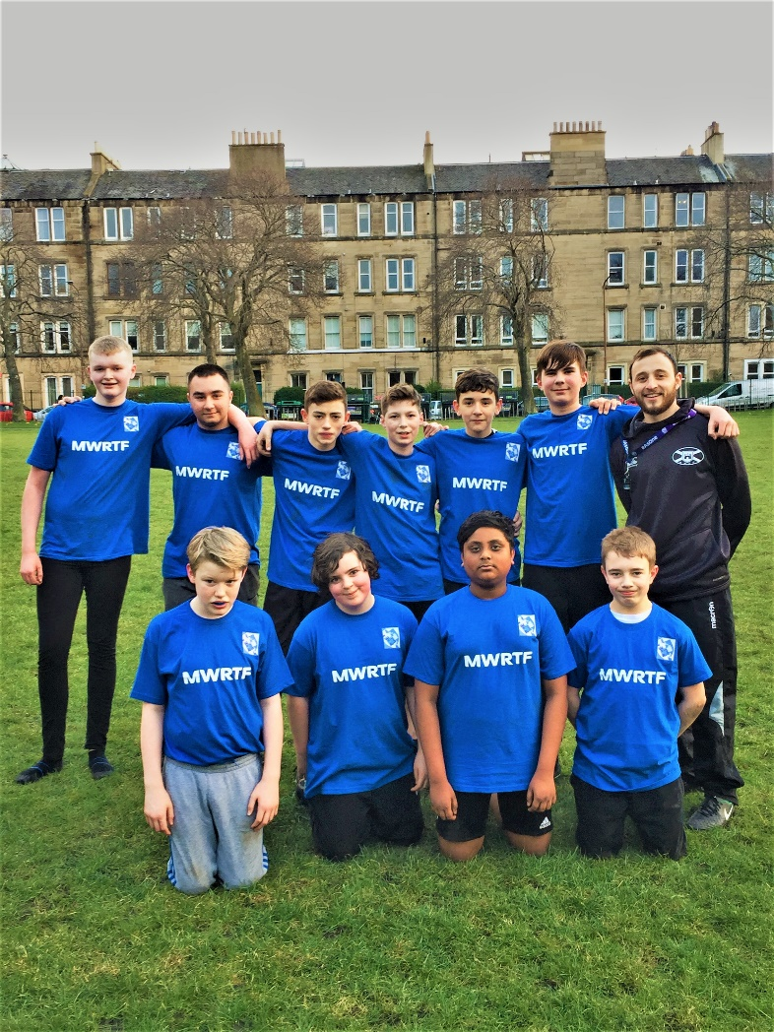

Murray with the players

Murrayfield Wanderers Rugby Trust Foundation

Charity Registered in Scotland No: SC039024

Future Plans:

We would love to receive further financial support to:

- Continue our Personal Development Plan
- Provide and extend support for our Development Officer
- Roll out an expanded programme of activities for children and teenagers in Edinburgh
- Fund the development of Modern Apprentice students
Murrayfield Wanderers Rugby Trust Foundation
112 Roseburn Street, Edinburgh EH12 5PH
Telephone: 0131 337 8993 Email: aj@lomondadventures.com

Trustees:
Andrew Jones (Chair), Roy Leckie, Christian Bruce, Bruce Cartwright, Bill Fell, Gordon Murray

Consultant:
Mike Dawson

Development Officer:
Murray Hastie

Useful Links:

http://www.pitchero.com/clubs/murrayfieldwanderersfootballclub/

https://www.facebook.com/Murrayfieldwanderers/

https://twitter.com/wandiesrugby

MURRAYFIELD WANDERERS
RUGBY TRUST FOUNDATION
(Charity registered in Scotland: SC039024)

Gift Aid Form

Are you a UK taxpayer? If so, you can use Gift Aid to make your donations go further by completing this declaration. The MWRTF will reclaim 25p of tax on every £1 you give.

Please complete the form below and return to:

Murrayfield Wanderers Rugby Trust Foundation
112 Roseburn Street, Edinburgh EH12 5PH

Declaration
I would like the MWRTF to treat this and all future donations I make to the MWRTF as Gift Aid Donations until I notify you otherwise. I confirm that I am a UK taxpayer and understand that if I pay less Income Tax and/or Capital Gains Tax in the current tax year (6 April – 5 April) than the amount of Gift Aid claimed on all my donations it is my responsibility to pay any difference. I understand that Council Tax and VAT do not qualify.

Signed ______________________________________________

Date _____________________

Name ______________________________________________

Address ______________________________________________

______________________________________________

Postcode _____________________

Notes:

You must pay an amount of Income Tax and/or Capital Gains Tax for each tax year (6 April one year to 5 April the next) that is at least equal to the amount of tax that the MWRTF will reclaim on your gifts for that tax year. By signing the above declaration you confirm that you have paid or will pay such an amount of tax and that you understand Council Tax and VAT do not qualify.

- You can cancel this Declaration at any time by notifying the MWRTF in writing
- If your circumstances change and you no longer pay enough income or capital gains tax to cover the amount claimed by the MWRTF, you can cancel your declaration.
- If you pay Income Tax at the higher rate you must include all your Gift Aid donations on your Self-Assessment tax return if you want to receive the additional tax relief due to you.
- Please notify the MWRTF if you change your name or address.

