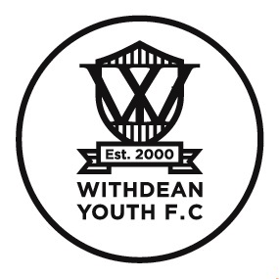
Withdean Youth FC
Team Manager / Coach Role & Responsibilities

- Who will I be responsible to?

- The Club Committee.

- Who will I be responsible for?

- Assistant Manager / Assistant Coach (if applicable)

- What is the role of Team Manager / Coach?

To be responsible for, and to provide leadership and direction in accordance to Club and FA guidelines to ensure, the successful running for all aspects of activity across an age group.

- What else can you tell me about the role?

Development of players and coaches in accordance to Club and FA policies, strategy and best practices.

Ensure all coaches, assistant coaches and helpers are registered with the Club, hold the correct level of accreditation and have been approved by the Club Welfare Officer.

- How much time will I need to give to the role?

Around 4 hours per week.

- What sort of tasks are involved?

- Ensure Child Welfare is always a priority within the age group.
- Ensure an inclusive, safe and fun environment for the players within the age group.
- Teams within age group are managed in accordance to Club and FA policies, strategy and best practices.
- Teams within age group are managed in accordance to league operating rules (player registration, match sheets, result reporting etc).
- Recruiting players, coaches and helpers.
- Attend matches and training sessions of teams responsible for.
- Management of players and parents/guardians expectations.
- Maintain safe equipment and kit and co-ordinate stock checks with the Kit co-ordinator

